CHAPTER 22 SOUND AND MUSIC

The integration of sound, music, and video into Microsoft Windows has been a significant advancement in the evolution of the operating system. Initially, multimedia support was introduced as the Multimedia Extensions to Windows in 1991. However, with the release of Windows 3.1 in 1992, multimedia support became a fully integrated category of APIs.

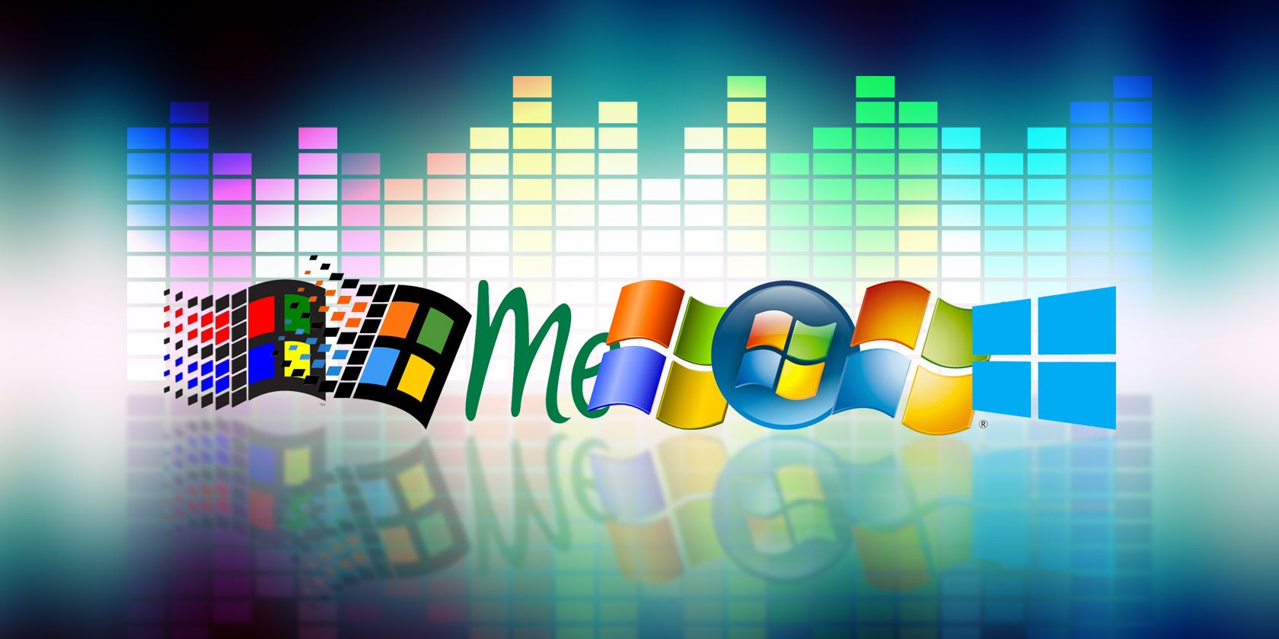

Over the years, the availability of CD-ROM drives and sound boards, which were considered rare in the early 1990s, has become a standard feature in new PCs. Nowadays, it is widely recognized that multimedia capabilities enhance the graphical user interface of Windows and add a valuable dimension to the computing experience. These features have extended the traditional role of computers beyond number crunching and text processing.

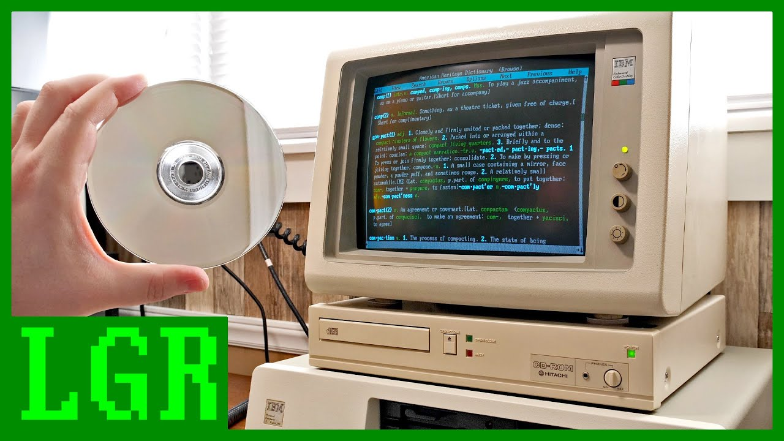

The integration of sound, music, and video into Windows has transformed the way users interact with their computers. It has opened up new possibilities for entertainment, communication, and creativity. From playing audio files and videos to creating multimedia presentations, Windows provides a platform for users to engage with various forms of media.

With each new version of Windows, including Windows 10, Microsoft has continued to enhance and expand multimedia capabilities. Windows 10 offers a wide range of features and tools that make it easier for users to enjoy and create multimedia content.

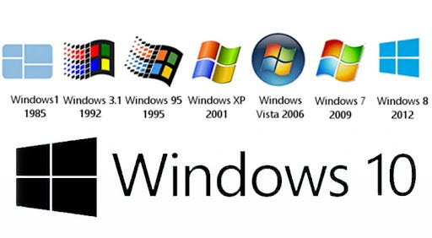

Media Player: Windows 10 includes the built-in Windows Media Player, which allows users to play a variety of audio and video file formats. It provides basic playback controls, playlist management, and the ability to create and manage media libraries.

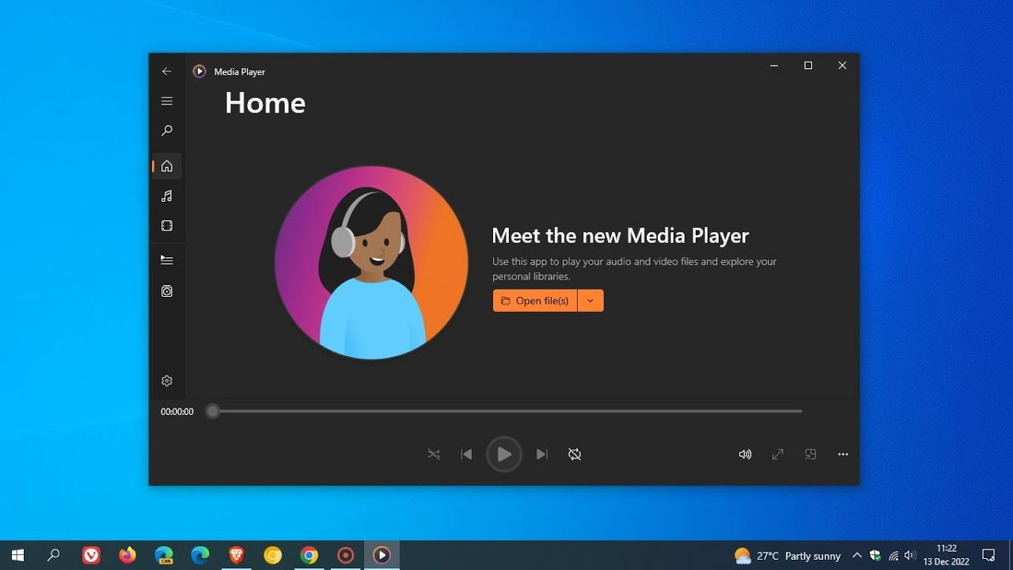

Groove Music: Windows 10 introduced the Groove Music app, which provides access to a vast library of songs and allows users to stream music from the Microsoft Store. It also supports local music playback and offers features like playlists, radio stations, and music recommendations.

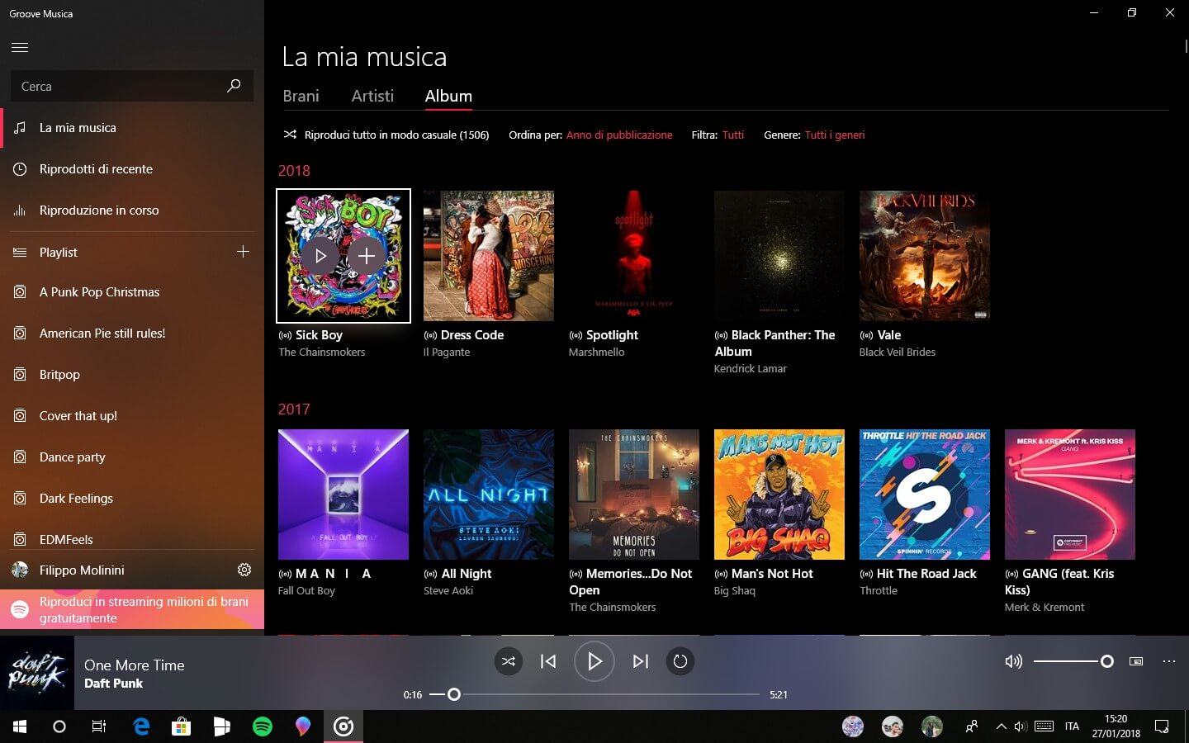

Movies & TV: The Movies & TV app in Windows 10 enables users to play movies and TV shows from their personal collection or purchase and rent content from the Microsoft Store. It supports a range of video formats and provides features such as playback controls, subtitles, and video casting.



Sound Settings: Windows 10 includes comprehensive sound settings that allow users to configure audio playback and recording devices, adjust volume levels, and apply audio enhancements. Users can also set default audio devices for different scenarios and customize sound effects.

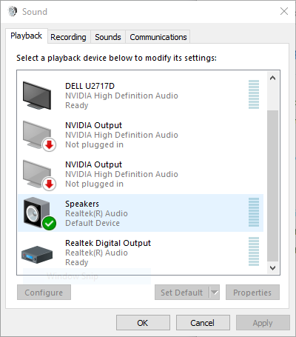

Recording and Editing: Windows 10 provides built-in tools for recording and editing audio and video content. The Voice Recorder app allows users to record audio notes, interviews, or lectures, while the Photos app offers basic video editing capabilities, such as trimming, adding music, and applying visual effects.

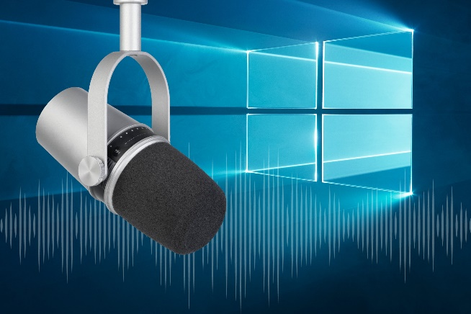 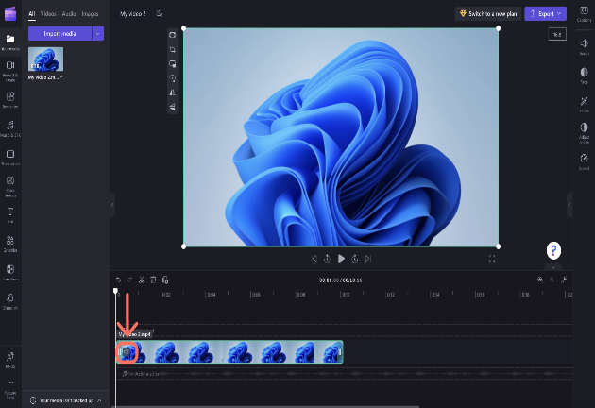

Gaming and Streaming: Windows 10 incorporates features specifically designed for gaming and streaming. The Xbox app allows users to record and capture gameplay, stream games to other devices, and communicate with fellow gamers. Additionally, the Game Bar provides quick access to gaming features, including audio settings and broadcasting options.

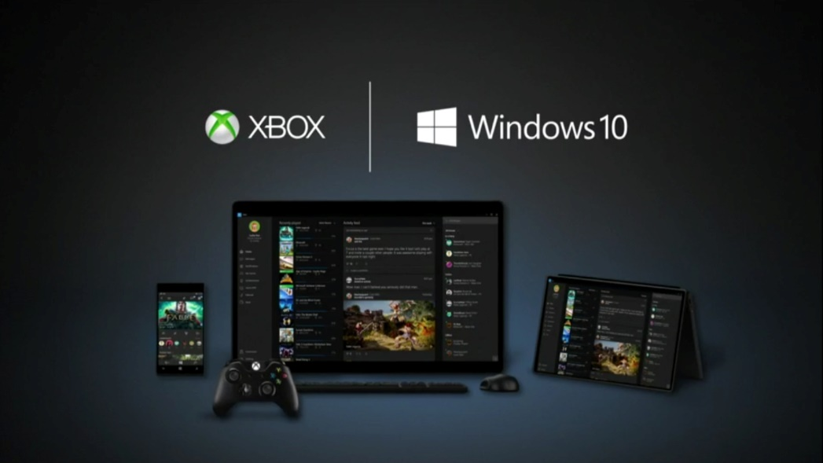

Virtual Reality and Mixed Reality: Windows 10 includes support for virtual reality (VR) and mixed reality (MR) experiences. The Windows Mixed Reality platform enables users to immerse themselves in virtual environments, play VR games, and enjoy 360-degree videos and photos.

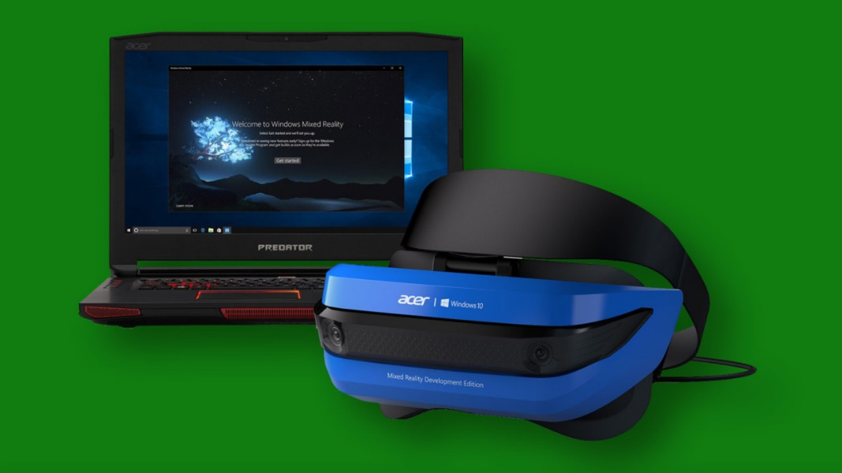

MULTIMEDIA CAPABILITIES

Multimedia capabilities are an essential and integrated part of the Windows operating system.

They encompass sound, music, and video, enhancing user experiences and extending the platform's capabilities.

Windows provides a device-independent multimedia API, which allows programmers to interact with various multimedia hardware devices through consistent function calls.

This device abstraction ensures compatibility and flexibility across different hardware configurations. Some of the key multimedia hardware devices supported by Windows include:

Waveform Audio Devices (Sound Cards): Sound cards convert analog audio signals from microphones and other input devices into digital samples for storage and processing (e.g., in .WAV files). They also convert digital waveforms back into analog sound for playback through speakers.

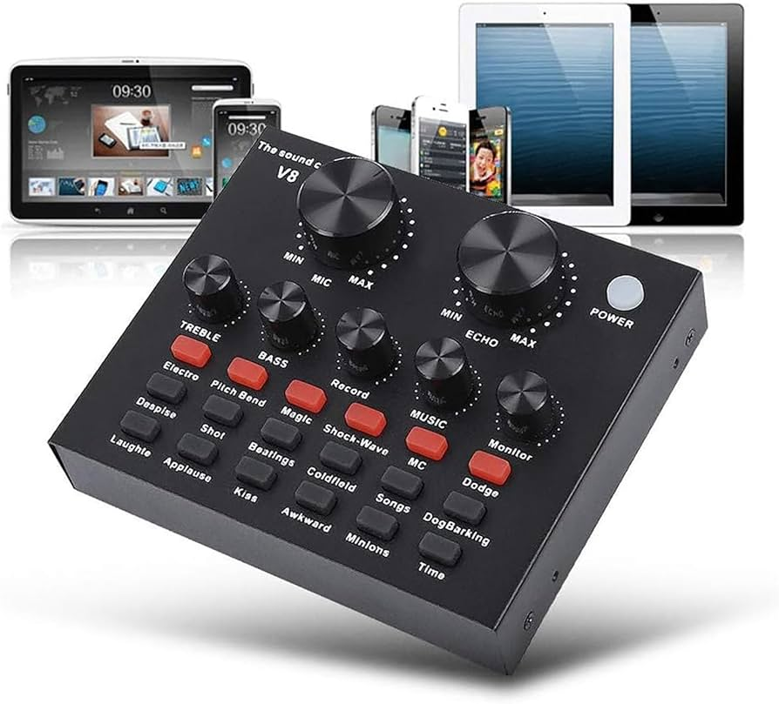

MIDI Devices: MIDI devices implement the Musical Instrument Digital Interface (MIDI) standard. They generate musical notes in response to MIDI messages and can interface with MIDI input devices such as musical keyboards and external synthesizers.



CD-ROM Drives (CD Audio): CD-ROM drives can play standard music CDs, allowing users to listen to audio tracks directly from the CD.



Video for Windows (AVI Video): Video for Windows is a software-based device in Windows that enables the playback of .AVI files (audio-video interleave). It provides support for playing video files and may also leverage video board hardware acceleration if available.



ActiveMovie Control: ActiveMovie Control expands video capabilities by providing support for additional movie formats, including QuickTime and MPEG. It can take advantage of video board hardware acceleration to enhance movie playback performance.

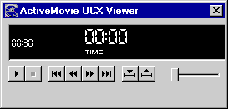

Laserdisc Players and VISCA Video Cassettes: Certain devices, such as laserdisc players and VISCA video cassettes, can be controlled via serial interfaces by PC software. This allows users to manage these devices and perform actions through their computer.

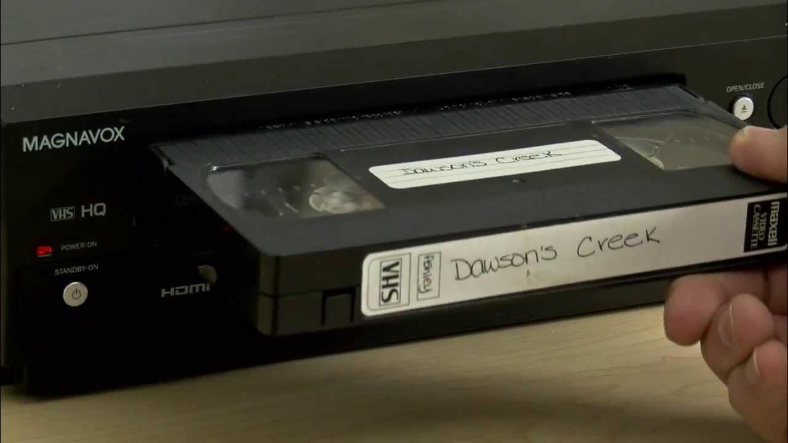

In addition to these hardware-specific features, Windows provides various core functionalities and concepts related to multimedia:

Device Abstraction: The Windows multimedia API abstracts the underlying hardware, providing a unified interface for programmers to access and control diverse multimedia devices. This allows developers to write multimedia applications that can work with different hardware configurations.

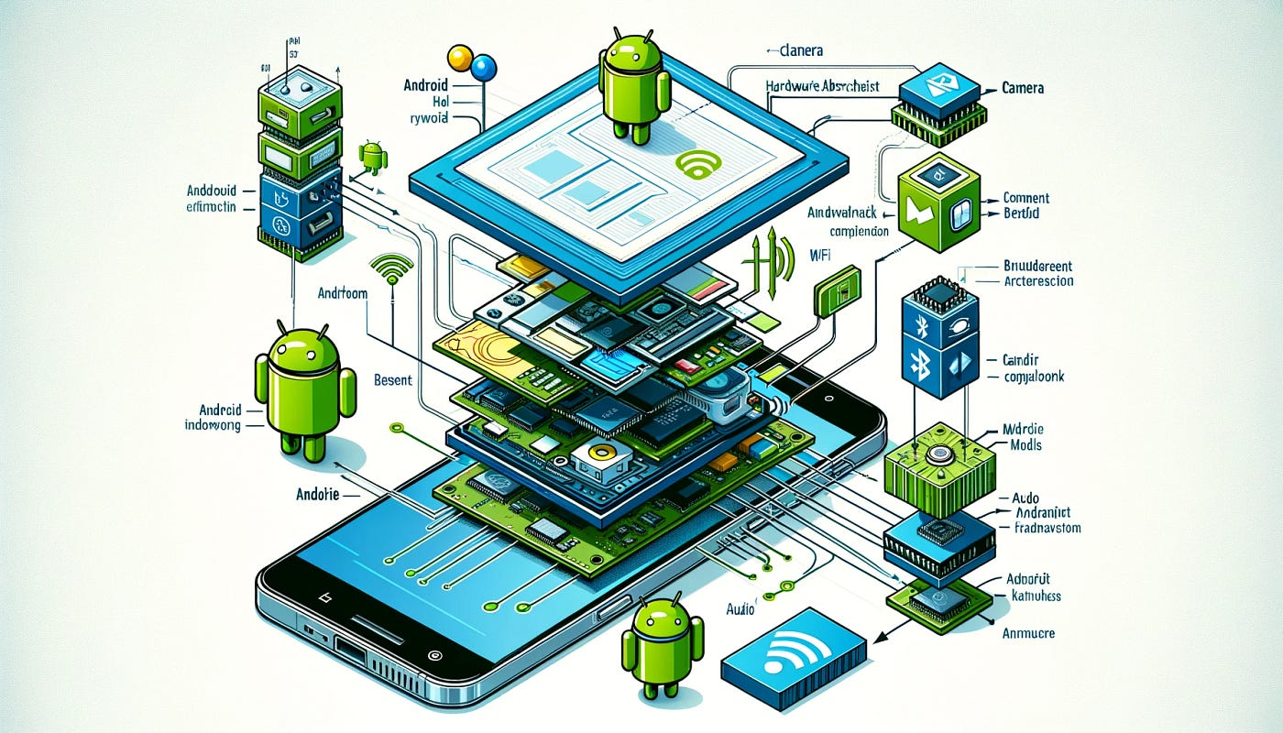

Hardware Mixing: Windows often includes a Volume Control application that allows users to blend output from multiple sources, such as waveform audio, MIDI, and CD audio. This enables users to control the relative volume levels of different audio streams.



Hardware Acceleration: Video boards can have dedicated hardware components that accelerate movie playback. This hardware acceleration improves performance and allows for smoother and more efficient video rendering.

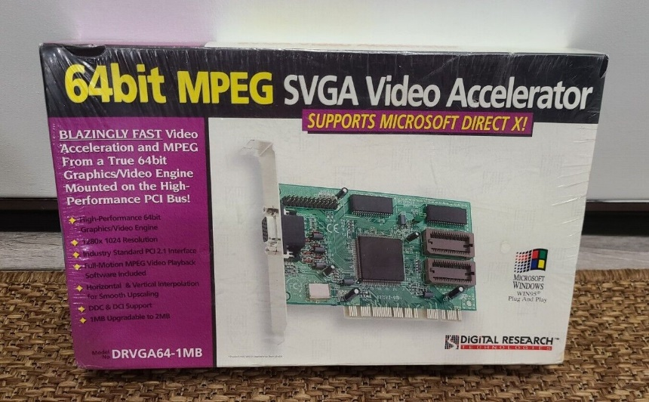

Serial Interface Control: Some multimedia devices, like laserdisc players and VISCA video cassettes, can be controlled via serial communication interfaces. This allows users to send commands and manage these devices directly from their computer.

 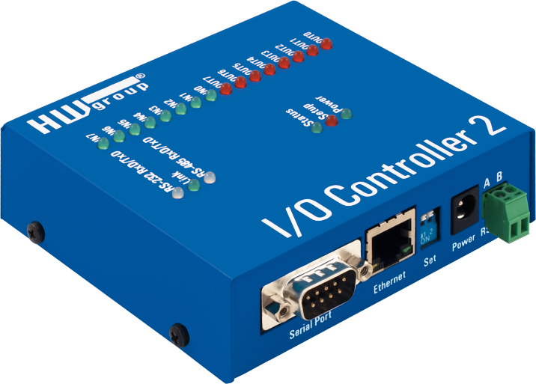

Overall, multimedia support in Windows has evolved significantly since its introduction as the Multimedia Extensions in 1991. With the widespread availability of CD-ROM drives and sound cards, multimedia capabilities have become standard in modern PCs. The integration of sound, music, and video into Windows has transformed the platform, going beyond traditional text and number processing and enabling immersive experiences for users.

Strategic API Design:

Dual-Layer Approach: Windows offers both low-level and high-level multimedia APIs, each serving distinct purposes and catering to different developer needs.

Low-Level Interfaces: Provide direct, granular control over hardware, enabling fine-tuning and optimization for demanding tasks or unique functionalities.

High-Level Interfaces: Simplify common operations, reducing development time and promoting code readability, often at the expense of some flexibility.

Low-Level Interfaces: Unleashing Hardware Potential:

Waveform Audio Mastery: waveIn and waveOut functions enable the recording and playback of digital audio signals, crucial for voice applications, music production software, and sound effects.

MIDI Orchestration: midiOut, midiIn, and midiStream functions control MIDI devices, essential for music creation software, interactive game audio, and sequencing hardware synthesizers.

Precision Timing: time functions establish high-resolution timers, ensuring accurate synchronization of multimedia events, particularly MIDI playback and real-time audio processing.

High-Level Interfaces: Streamlining Development:

MCI: The Versatile Orchestrator:

Offers a consistent interface for diverse multimedia devices, promoting code reusability and streamlining multi-device projects.

Its string-based form empowers rapid prototyping and scripting, enabling experimentation and customization.

Supports a comprehensive range of devices, encompassing audio, video, and optical media, fostering multifaceted multimedia experiences.

Beyond the Core: Expanding Possibilities:

*DirectX API: Powering Immersive Experiences:*

* While not extensively covered here, DirectX stands as a cornerstone for game development, multimedia applications, and graphics-intensive software.
* It provides unparalleled hardware acceleration, sophisticated 3D graphics rendering, advanced audio processing, and robust input device support.

*Convenient Sound Utilities:*

* MessageBeep: Offers a straightforward mechanism for auditory feedback, enhancing user interaction and signaling important events.
* PlaySound: Simplifies the incorporation of sound effects and music into applications, contributing to engaging user experiences.

Key Considerations for API Selection:

* Project Requirements: The choice of API hinges on the specific needs of the application, balancing performance, ease of development, and hardware access requirements.
* Developer Expertise: Familiarity with low-level programming concepts is essential for effective use of low-level interfaces, while high-level interfaces often align with broader programming knowledge.
* Target Hardware: Understanding the capabilities of the intended multimedia hardware is crucial for optimal API selection and feature utilization.

TESTMCI PROGRAM

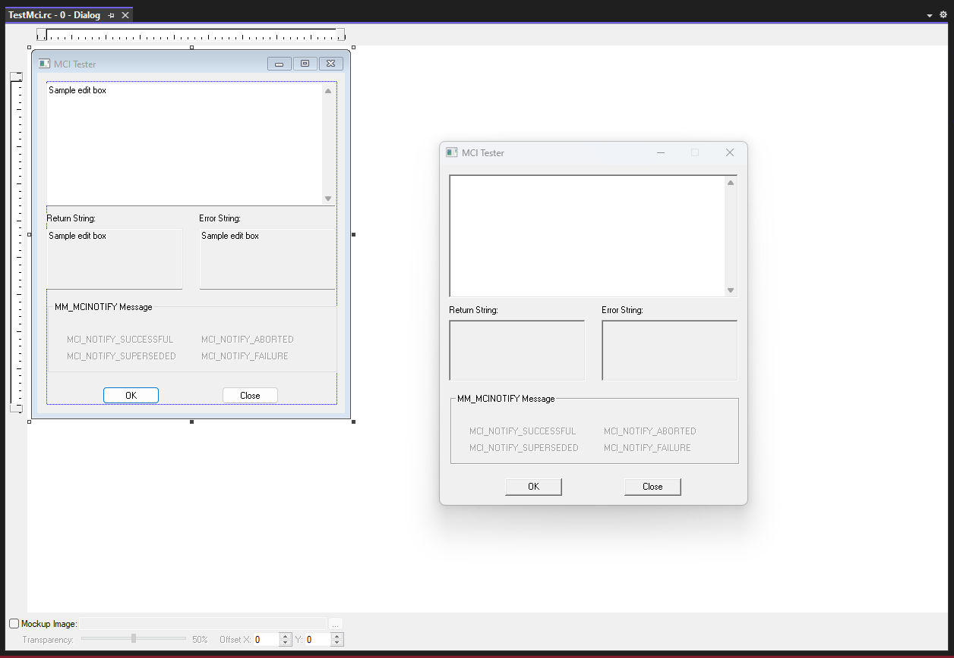

The TESTMCI program is a C application that allows users to interactively test and experiment with MCI (Media Control Interface) commands. MCI commands are used to control multimedia devices and perform operations such as playing audio or video files.

The program provides a simple graphical user interface (GUI) based on a modeless dialog box. The main window of the program contains an edit box where users can enter MCI commands. When the user presses Enter or clicks the OK button, the program retrieves the command from the edit box and passes it to the mciSendString function.

The mciSendString function is a key function provided by the MCI API. It takes a command string as input and executes the specified MCI command. In the TESTMCI program, the command string is obtained from the edit box, and the result of the command execution is stored in a string buffer.

After executing the command, the program displays the result in the "Return String" section of the window. This can include information such as status messages or data returned by the MCI command.

Additionally, the program retrieves the error code returned by the mciSendString function. If an error occurs during the execution of the command, the error code is used with the mciGetErrorString function to obtain a textual description of the error. The error description is then displayed in the "Error String" section of the window.

The program supports selecting multiple lines in the edit box. If multiple lines are selected, each line is treated as a separate MCI command and executed sequentially. The program processes each line individually and displays the corresponding result and error description for each command.

The program also includes a section for handling the MM_MCINOTIFY message. This message is sent by the MCI subsystem to notify the application of changes in the status of multimedia devices or completion of asynchronous operations. The program enables or disables various controls in response to this message.



Overall, the TESTMCI program provides a convenient way for developers or users to experiment with MCI commands and observe their effects. It allows for interactive testing and troubleshooting of multimedia operations using the MCI API.

UNDERSTANDING MCI COMMANDS IN TESTMCI PROGRAM:

The TESTMCI program demonstrates the use of Multimedia Command Strings through two essential functions: mciSendString and mciGetErrorText. Here's an in-depth breakdown of the program's functionality:

mciSendString Function:

* The primary multimedia function used in TESTMCI is mciSendString. This function is responsible for sending command strings to the MCI subsystem for execution.
* When you type a command into the main edit window and press Enter, the program passes the entered string as the first argument to mciSendString.
* If multiple lines are selected in the edit window, the program sends them sequentially to mciSendString.
* The second argument to mciSendString is the address of a string (szReturn) that receives information back from the function.
* The returned information is then displayed in the "Return String" section of the program's window.

mciGetErrorText Function:

* The error code returned from mciSendString is passed to the mciGetErrorText function to obtain a text error description.
* The obtained error description is displayed in the "Error String" section of TESTMCI's window.

CD Audio Control:

* The program showcases the control of a CD-ROM drive to play audio CDs using MCI commands.
* Commands like open cdaudio, play cdaudio, pause cdaudio, and stop cdaudio are utilized to control audio playback.
* The "Return String" section displays information returned by the system in response to these commands.

Understanding Time Formats:

* The program allows users to interact with CD Audio by querying information like the total length of the CD, the number of tracks, and the length of individual tracks.
* Commands like status cdaudio length and status cdaudio number of tracks provide this information.
* The time format for CD Audio is explained, with examples like status cdaudio time format returning "msf" (minutes-seconds-frames).

Setting and Manipulating Time:

* The program demonstrates how to set and manipulate time formats, such as changing the time format to "tmsf" (tracks-minutes-seconds-frames).
* Users can play specific tracks or set the playback range using commands like play cdaudio from with specified time values.

Additional Features:

* The program handles error conditions gracefully, displaying appropriate messages in case of failures.
* It provides a practical and interactive way to explore MCI commands for CD Audio control.

Use of wait and notify Options:

* The explanation of the wait and notify options adds valuable insights into managing the behavior of MCI commands.
* The wait option ensures that mciSendString doesn't return control until the specified operation is completed. However, caution is advised to prevent unintended consequences.
* The break command is introduced as a safety mechanism when using wait, allowing the user to interrupt a potentially lengthy operation.

Combining wait and notify Options:

* The passage mentions that you can use the wait and notify options together, although it suggests that there's hardly a reason for doing so. This highlights the flexibility of MCI commands.

Handling MM_MCINOTIFY Messages:

* The notify option, when used, allows the program to receive an MM_MCINOTIFY message after the completion of the specified MCI operation.
* The TESTMCI program displays the result of this message in the MM_MCINOTIFY group box, enhancing user interaction and feedback.

Scripting MCI Commands:

* The passage introduces the concept of constructing MCI "scripts" by selecting and executing a series of MCI commands.
* This scripting capability allows users to automate a sequence of operations, providing a practical way to manage multimedia tasks efficiently.

CD Player Mimicry:

* The suggestion of constructing a simple application that mimics a CD player is intriguing. It highlights the potential for creating user-friendly interfaces for controlling CD playback, displaying track information, and leveraging the Windows timer for periodic updates.

Synchronization of On-Screen Graphics with CD:

* The idea of synchronizing on-screen graphics with CD audio opens up creative possibilities, such as music instruction or custom graphical music videos.
* This feature could enhance the user experience and extend the application of multimedia commands beyond basic playback control.

WAVEFORM AUDIO IN WINDOWS: AN IN-DEPTH EXPLORATION

Waveform audio stands as a cornerstone of multimedia features in the Windows operating system, offering a robust set of capabilities for capturing, processing, and playing back sounds. At its core, waveform audio transforms analog sound vibrations into digital data, allowing for efficient storage and retrieval in files with the .WAV extension.

Understanding the Physics and Perception of Sound:

Before delving into the intricacies of the waveform audio API, it's crucial to grasp the fundamental principles of sound. Sound, fundamentally, is a manifestation of vibration. In the context of human perception, sound is experienced as variations in air pressure acting on the eardrums. A microphone serves as the gateway to translating these vibrational patterns into electrical currents.



In traditional analog mediums like audio tapes and phonograph records, the storage of sound involves encoding vibrations into magnetic pulses or physical grooves. As these electrical currents are further processed, they give rise to waveforms that graphically depict the fluctuations of vibrations over time. The sine wave, a natural representation of vibration, emerges as a fundamental waveform, showcasing one complete cycle in Figure 5−7 of this book.

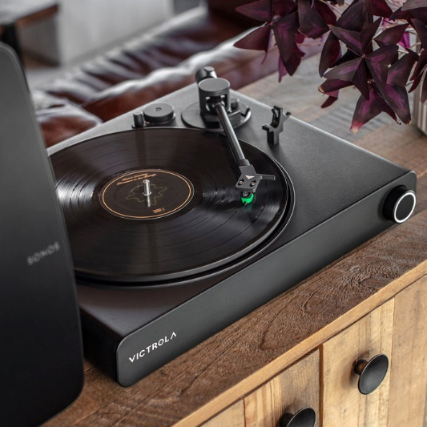

Parameters of Sound:

The sine wave introduces two critical parameters – amplitude and frequency. Amplitude, denoting the peak value of a wave over a single cycle, corresponds to our perception of loudness. On the other hand, frequency, determining the number of cycles per second, translates to our perception of pitch. The human auditory system exhibits sensitivity to sine waves across a spectrum, from low-pitched sounds at 20 Hz to high-pitched ones at 20,000 Hz. However, this sensitivity diminishes with age, particularly in the higher frequency range.

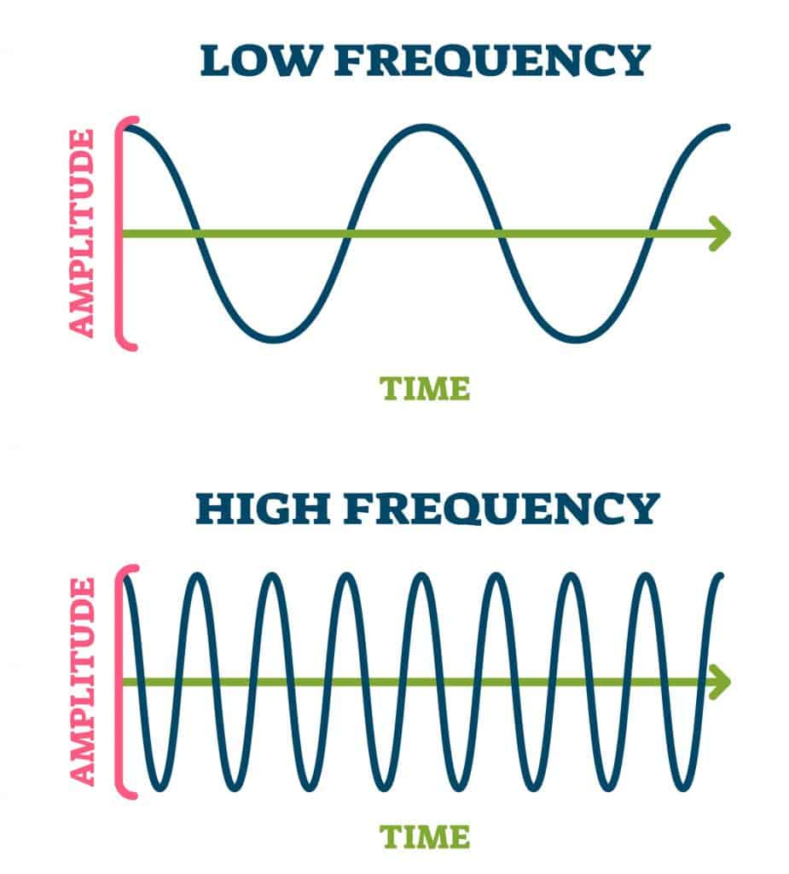

Waveform Audio API:

Armed with an understanding of sound's physical representation, the waveform audio API in Windows becomes a powerful tool. This API facilitates the capture of sounds through microphones, converting them into numerical data. These digitized waveforms can then be stored in memory or on disk in the widely recognized .WAV file format. Subsequently, the stored sounds can be played back, enabling diverse applications in multimedia development.

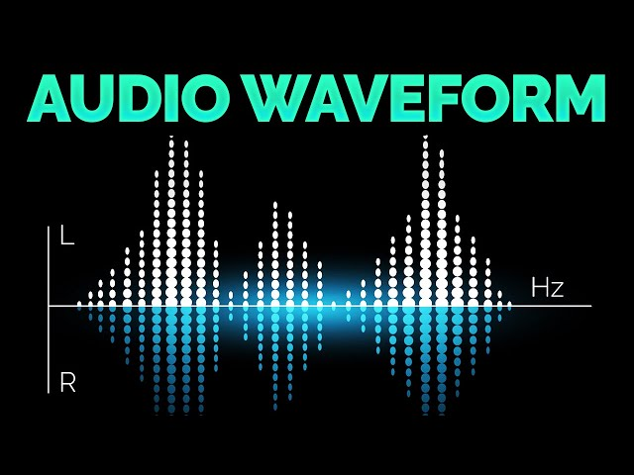

Applications and Implications:

The significance of waveform audio extends beyond its technical implementations. It forms the backbone of various audio applications, from basic sound recording to sophisticated multimedia projects. Understanding the physics of sound and the digital representation of waveforms lays the groundwork for harnessing the full potential of Windows' waveform audio capabilities.

 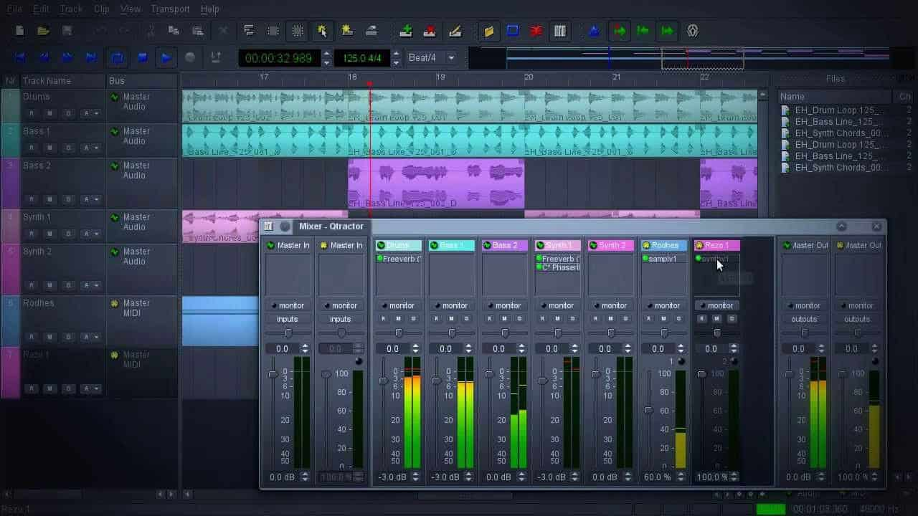

The Logarithmic Nature of Human Frequency Perception:

The human perception of frequency is inherently logarithmic, not linear. In practical terms, this means that the perceived difference between 20 Hz and 40 Hz is akin to the difference between 40 Hz and 80 Hz. This logarithmic sensitivity defines the musical concept of an octave, where frequency doubles. The human ear can discern sounds across approximately 10 octaves. To put this in perspective, the range of a piano spans a little over 7 octaves, from a low of 27.5 Hz to a high of 4186 Hz.

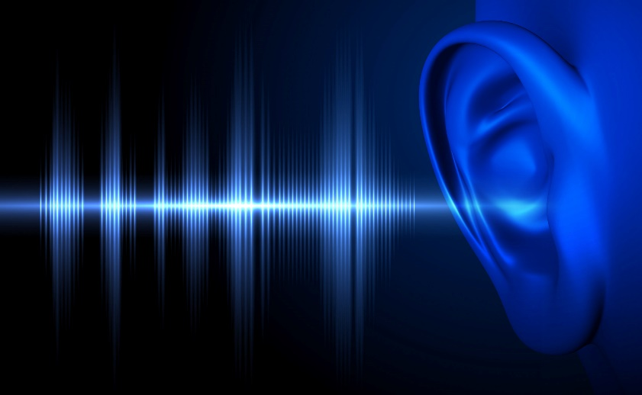

Complexity of Sound and Fourier Series:

While sine waves represent a natural form of vibration, they rarely occur in nature in pure forms, and, moreover, they often produce uninteresting sounds. Most sounds are much more complex. The concept of a Fourier series, attributed to Jean Baptiste Joseph Fourier, comes into play here. Any periodic waveform, one that repeats itself, can be deconstructed into multiple sine waves. These sine waves, known as overtones, have frequencies that are integer multiples of the fundamental frequency, also called the first harmonic. The second harmonic is the first overtone, and so forth.



Timbre and Harmonics:

The unique sound quality of each periodic waveform, influenced by the relative intensities of its sine wave harmonics, is termed "timbre." This characteristic is what differentiates, for example, a trumpet from a piano. Each instrument has a distinct pattern of harmonic intensities that contributes to its overall timbre.

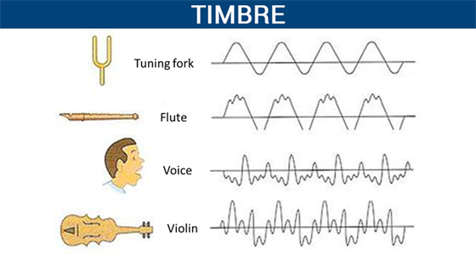

Different instruments and their timbres.

Timbre is mainly determined by the harmonic content of a sound and the dynamic characteristics of the sound. A sound must have one fundamental frequency and seven or more additional harmonics to have timbre.

The harmonic series is the set of frequencies f, 2f, 3f, 4f, etc.. The second harmonic always has exactly half the wavelength (and twice the frequency) of the fundamental.

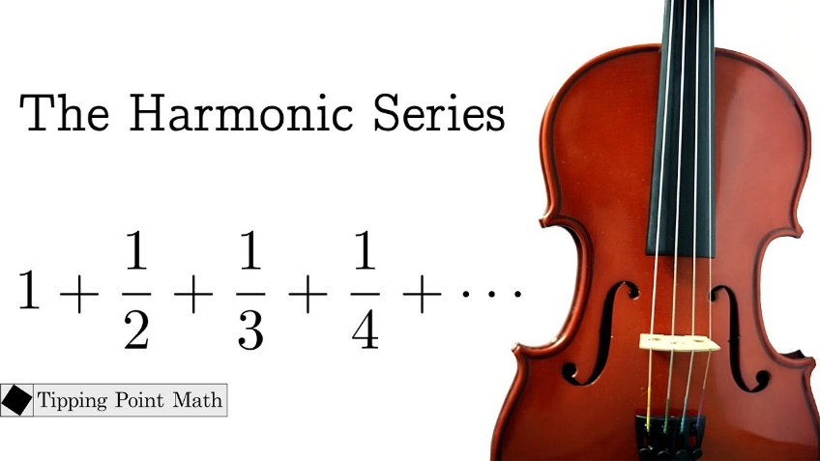

Real-World Complexity and Synthesis Challenges:

Historically, there was a belief that synthesizing musical instruments electronically simply required breaking down sounds into harmonics and reconstructing them using multiple sine waves. However, the reality is more intricate.

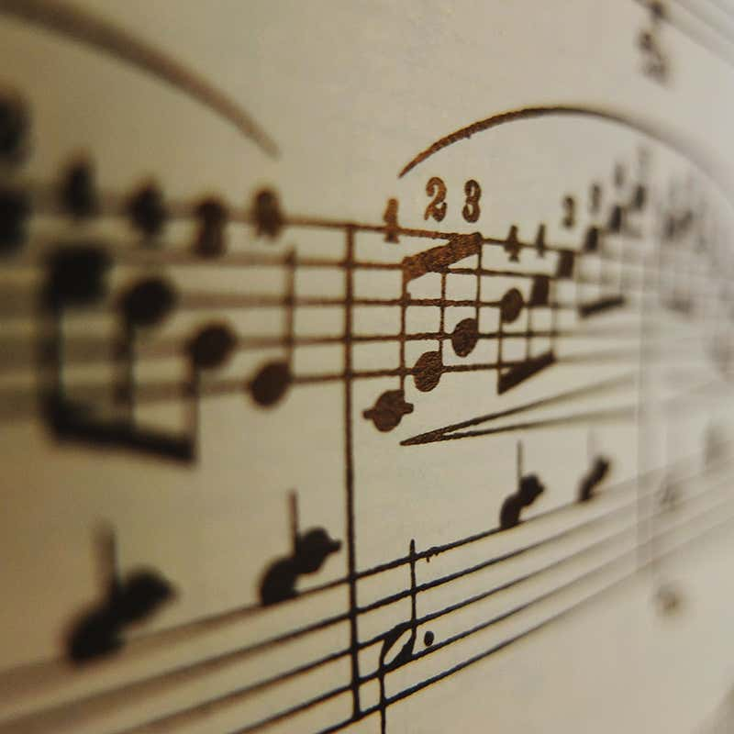

Real-world sounds from musical instruments are never strictly periodic. Harmonic intensities vary across the instrument's range, and these intensities change dynamically as each note is played. The initial phase of a note, known as the attack, can be particularly complex and is crucial to our perception of timbre.

Digital Storage and Sound Representation:

With advancements in digital storage capabilities, it has become feasible to store sounds directly in digital form without the need for intricate deconstruction. This has revolutionized the way we handle and reproduce complex sounds, enabling a more direct and efficient representation of the rich tapestry of real-world audio.

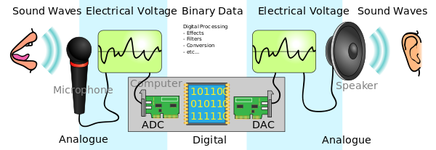

SOUND'S JOURNEY INTO THE DIGITAL REALM: PULSE CODE MODULATION

The Challenge of Digital Sound Representation: To understand PCM, we must first grasp the fundamental difference between analog sound waves and the digital language of computers. Sound, as we experience it, exists as continuous fluctuations in air pressure, forming smooth, wave-like patterns.

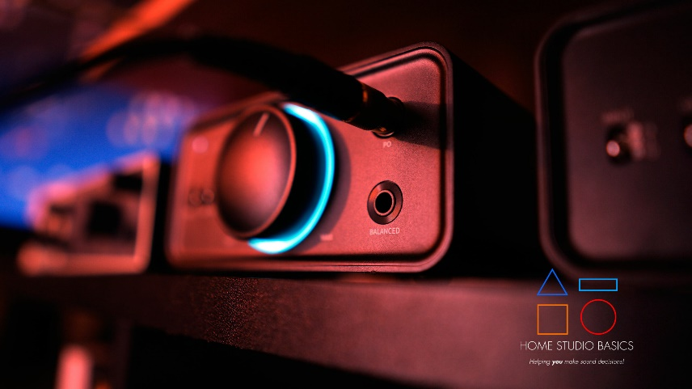

Computers, on the other hand, operate in a world of discrete numbers, requiring a translation process to bridge this divide. PCM stands as a cornerstone of this translation, enabling the accurate representation of sound within digital systems.

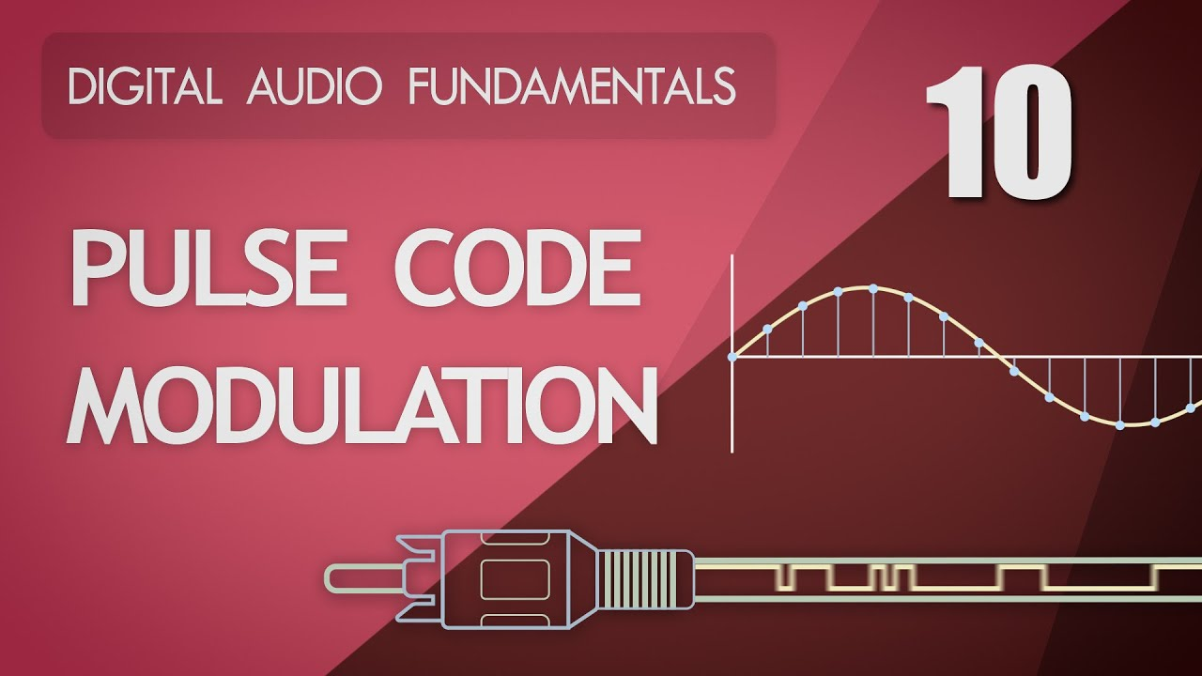

Capturing Sound's Essence in Snapshots and Numbers:

Sampling: Capturing Sound's Silhouette: Imagine a sound wave as a vast, undulating landscape. PCM's initial step involves meticulously measuring the wave's height (amplitude) at regular intervals, akin to taking snapshots of the terrain at specific points along its journey. This process, known as sampling, typically occurs thousands of times per second, determining the level of detail captured in the digital representation.

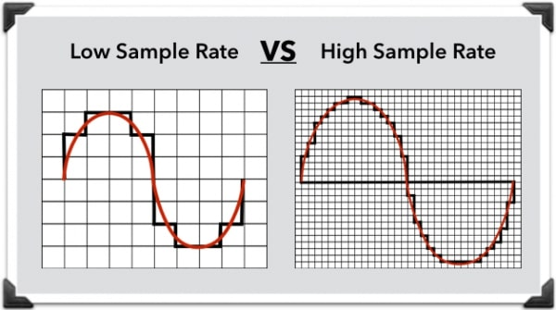

Quantization: Assigning Numerical Elevations: Each amplitude measurement, serving as a snapshot of the sound wave's shape, is then assigned a numerical value. This step, called quantization, resembles assigning elevations on a map. The precision of these values is governed by the sample size, measured in bits. Like the scale of a map, a larger sample size allows for finer detail, while a smaller sample size offers a broader, less granular representation. Specialized hardware, known as analog-to-digital converters (ADCs), expertly handles this delicate translation from wave to numbers.

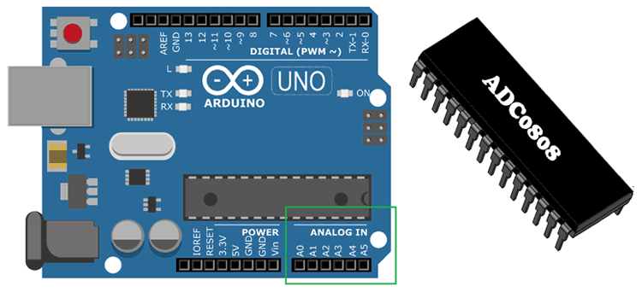

Reconstructing Sound's Symphony from Digital Data:

Reversing the Journey: Digital-to-Analog Conversion: To recreate sound from its digital form, PCM reverses the process. Digital-to-analog converters (DACs) act as cartographers, converting numerical values back into corresponding electrical wave amplitudes, carefully tracing the contours of the original sound wave.

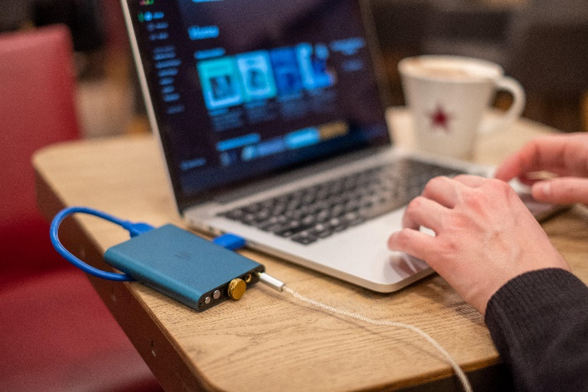 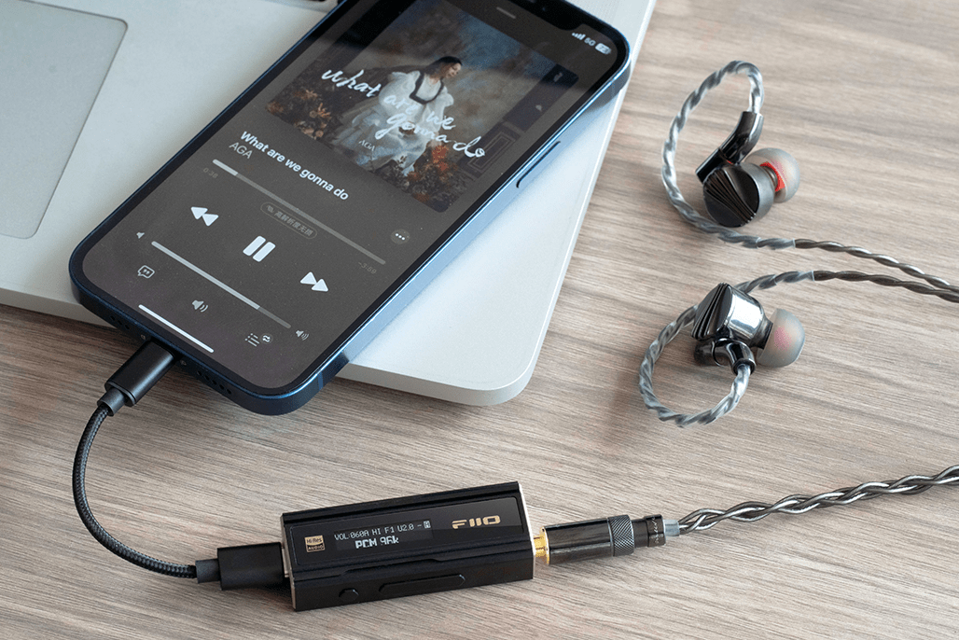

Smoothing Out Digital Edges: Similar to how a sculptor might refine a clay model, low-pass filters play a crucial role in PCM's reconstruction process. These filters, often likened to fine sandpaper, smooth out any sharp edges or abrupt transitions that might arise due to the inherent approximation of digital representation. This delicate refinement ensures a more natural, pleasing sound output.

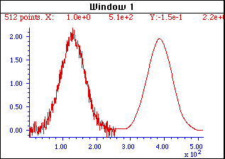

Balancing Fidelity and Efficiency: The Art of Sampling and Quantization:

Sampling Rate and Sample Size, Digital Audio's Guiding Parameters: Two key parameters fundamentally govern PCM's accuracy in replicating sound: sampling rate and sample size. Sampling rate dictates how often amplitude measurements are taken, while sample size determines the precision with which these measurements are stored.

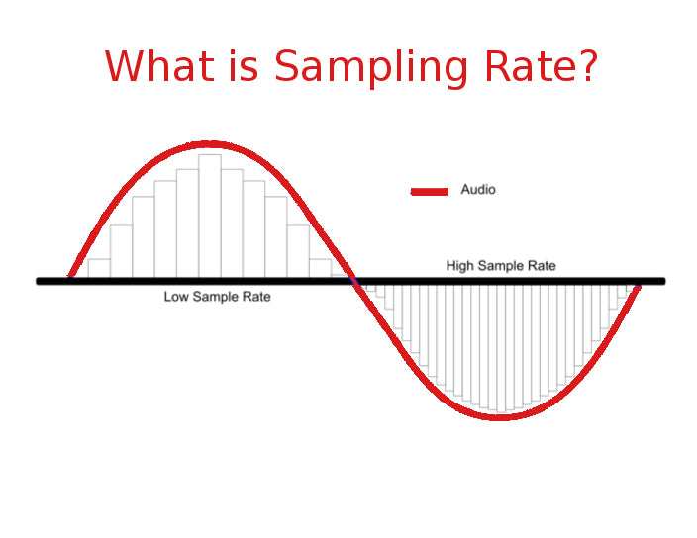

Finding Harmony, The Delicate Dance of Detail and Efficiency: Higher sampling rates and larger sample sizes capture more detail, potentially leading to more faithful sound reproduction. However, this increased detail comes at a cost, as it demands more data storage and processing resources. Thus, finding the optimal balance between fidelity and efficiency is crucial in PCM applications. Striking this balance ensures high-quality sound without placing excessive demands on storage and processing capabilities.

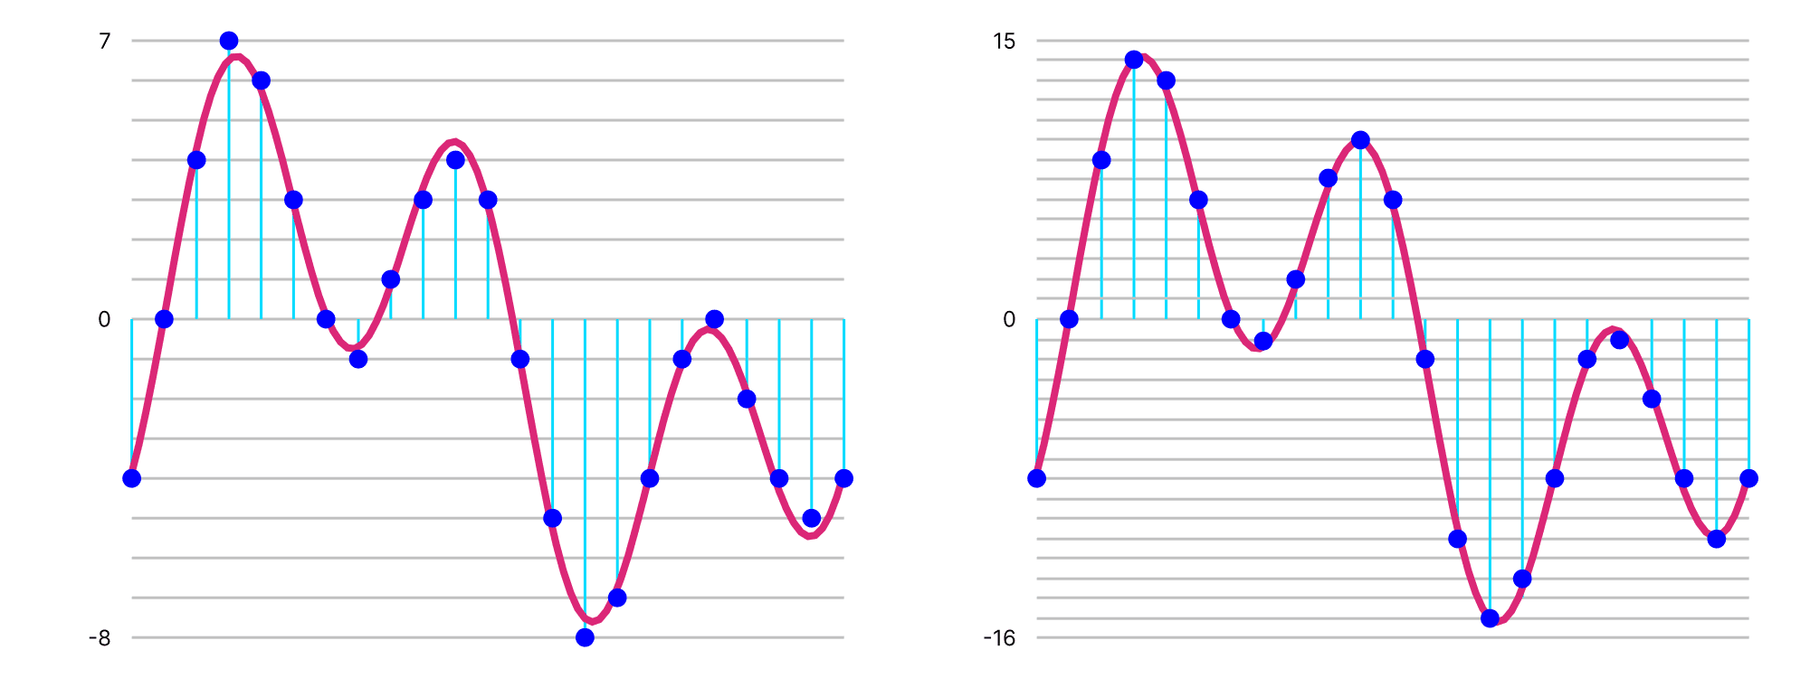

Sample Rate:

Expert Explanation: The sample rate is the number of snapshots or measurements taken per second from an analog signal to convert it into a digital format. It determines how frequently the amplitude of a sound wave is recorded.

Teen-Friendly Explanation: Imagine you're taking pictures of your favorite band at a concert. The sample rate is like how often you snap a photo. The more photos you take per second, the more accurate your representation of the band's performance.

Sample Size:

Expert Explanation: The sample size is the number of bits used to store each snapshot or measurement of the amplitude during the analog-to-digital conversion. It influences the level of detail and precision in representing the original sound.

Teen-Friendly Explanation: Think of the sample size as the quality of each photo you take. A larger sample size is like taking pictures with more pixels, providing a clearer and more detailed image of the music.

In a nutshell, sample rate is how often you capture moments of the sound, and sample size is how much detail each captured moment holds. It's like taking a lot of detailed pictures quickly to create a digital version of your favorite song.

SAMPLE RATE IN DEPTH

Sampling Rate: Capturing Sound's Delicate Details

Setting the Sound Stage: Sampling rate, measured in samples per second (Hz), is the cornerstone of digital audio, defining the frequency range that can be accurately captured and reproduced. It dictates how often snapshots of the sound wave's amplitude are taken, forming the foundation for its digital representation.



Nyquist's Crucial Rule: Doubling for Clarity: To faithfully reproduce sound, the sampling rate must be at least twice the highest frequency present in the original audio signal. This concept, known as the Nyquist frequency, ensures that enough information is captured to avoid distortion and create a faithful representation.

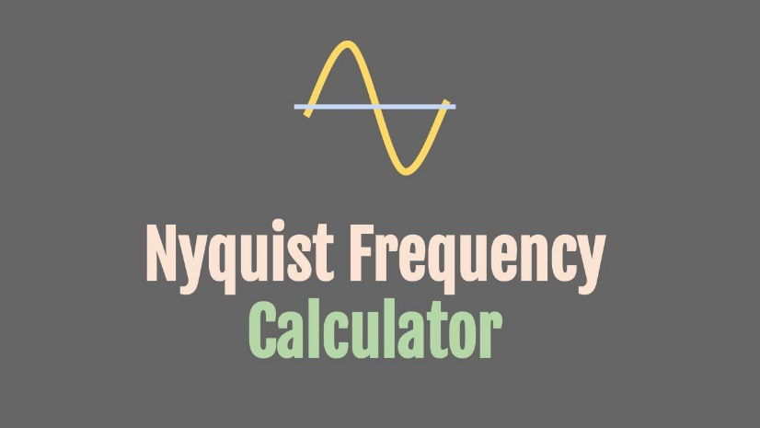

Aliasing: The Perils of Insufficient Sampling

Creating Phantom Frequencies: When the sampling rate falls below the Nyquist frequency, a phenomenon called aliasing occurs. This results in lower-frequency artifacts, or "aliases," appearing in the digital audio, often sounding like unintended, distorted echoes of the original sound.

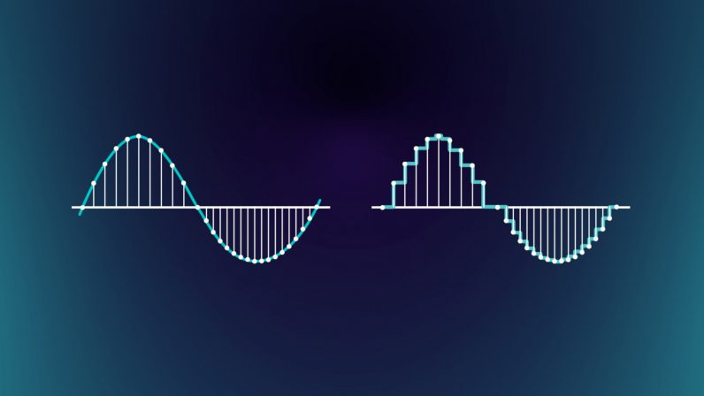

Guarding the Gates with Filters: To prevent aliasing, low-pass filters are strategically employed on both the input and output sides of the audio system. These filters act as gatekeepers, blocking frequencies above half the sampling rate, ensuring a clean and accurate representation.



Common Sampling Rates: Balancing Quality and Efficiency

CD-Quality Sound: 44.1 kHz: This widely adopted standard for audio CDs stems from a balance of factors:

* Capturing the full audible range for humans (up to 20 kHz).
* Accounting for the roll-off effect of low-pass filters.
* Enabling synchronization with video frame rates.

Voice and Lower Fidelity: Lower Rates for Different Needs: Sampling rates of 22.05 kHz, 11.025 kHz, and 8 kHz are often used for applications where less frequency detail is required, such as voice recordings or smaller file sizes.

Fundamentals vs. Overtones: Capturing True Musical Essence

The Importance of Overtones:

While a piano's highest fundamental frequency might be 4186 Hz, its rich, complex sound relies heavily on overtones, which are higher-frequency harmonics that contribute to its timbre and fullness. Lower sampling rates that cut off these overtones can result in a thin, less vibrant sound.

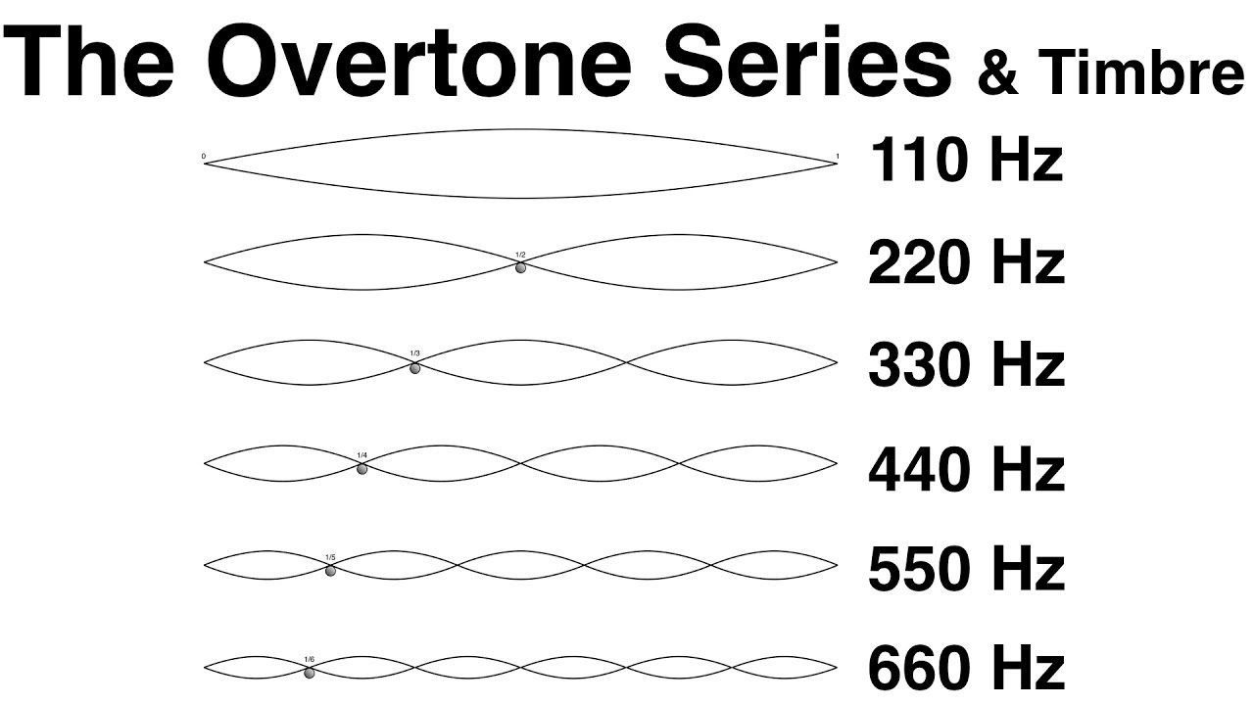

Expert Explanation:

Overtones are higher-frequency components that accompany the fundamental frequency of a sound. When a musical instrument, like a piano, produces a note, it's not just a single pure tone but a combination of various frequencies. The fundamental frequency is the lowest, defining pitch, while overtones are multiples of that frequency.

For instance, if the fundamental frequency is 100 Hz, the first overtone would be at 200 Hz, the second at 300 Hz, and so on. Overtones give each instrument its unique sound, known as timbre. In the case of a piano, overtones contribute to the richness and complexity of the music we hear.

When sampling sound, especially music, it's crucial to capture not only the fundamental frequency but also these overtones. They play a significant role in creating the true essence and character of the sound. Lower sampling rates might miss these higher-frequency components, resulting in a less authentic representation of the instrument.

Teen-Friendly Explanation:

Okay, let's break down overtones! Imagine your favorite song as a recipe. The main ingredient is the fundamental frequency, like the main spice in your dish. Now, overtones are like extra flavors that make the dish (or music) super tasty.

So, when a guitar string vibrates, it doesn't just make one sound; it's like a mix of different notes, kind of like a secret recipe. The main note is the fundamental frequency, and the extra notes are the overtones. They give each instrument its special taste, making a guitar sound different from a piano, even if they play the same note.

Now, if we don't catch these extra flavors when we record music (sampling), it's like having a bland dish without all the yummy spices. So, when we talk about sampling rates, we want to make sure we capture not just the main taste but all those delicious overtones to keep the music sounding rich and authentic!

Key Takeaways:

* Sampling rate is a crucial factor in digital audio quality.
* The Nyquist frequency sets a minimum threshold for accurate representation.
* Aliasing can occur when sampling rates are too low.
* Low-pass filters help prevent aliasing.
* Different sampling rates are used for various applications, balancing quality and efficiency.
* Overtones play a vital role in the richness of musical sounds.

SAMPLE SIZE: CAPTURING SOUND'S DYNAMIC RANGE

Measuring Sound's Nuances: Sample size, measured in bits, determines the dynamic range of a digital audio system. It dictates the precision with which amplitude measurements are stored, defining the range from the softest to the loudest sounds that can be accurately represented.

Creating a Digital Palette: Each additional bit doubles the number of possible amplitude levels, expanding the dynamic range. Imagine each bit as a brushstroke, adding finer detail to the audio painting.

Decibels: Quantifying Sound's Intensity:

Logarithmic Perception: Human hearing perceives sound intensity logarithmically, meaning we're more sensitive to changes in softer sounds than louder ones. The decibel (dB) scale reflects this, measuring sound intensity relative to a reference level.

Bels and Decibels: Honoring Bell's Legacy: The bel, named after Alexander Graham Bell, represents a tenfold increase in sound intensity. The decibel, one-tenth of a bel, signifies a barely perceptible change in intensity (about 1.26 times).

Calculating Dynamic Range:

The dynamic range in decibels between two sounds is calculated using the formula:

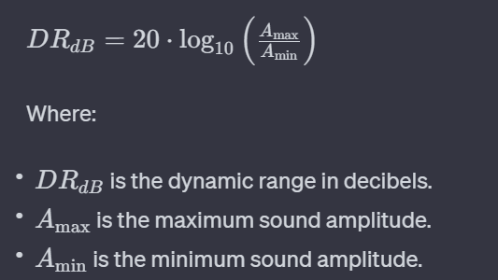

The dynamic range of a sound system, measured in decibels (dB), depends on the sample size, which represents the number of bits used to store the amplitude information of each sample. A larger sample size allows for a greater difference between the softest and loudest sounds, resulting in a higher dynamic range.

The formula to calculate the dynamic range for a given sample size is:

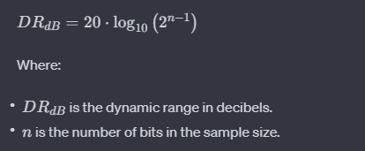

To figure out how much space we need for uncompressed audio, here's a simple formula:



For example, an hour of CD-quality sound (44,100 samples per second, 16 bits per sample, stereo) needs about 635 megabytes of storage, roughly what a CD can hold. So, the more bits and channels, the more space we need to keep all those musical details intact!

Common Sample Sizes and Their Impact:

8-bit Audio: Offers a dynamic range of about 48 dB, suitable for basic applications like voice recordings or sound effects.

16-bit Audio: Widely used in CDs and many digital audio systems, providing a dynamic range of approximately 96 dB, capturing a vast range of sounds from subtle whispers to powerful crescendos.

24-bit Audio: Often found in professional audio production, offering an impressive dynamic range of about 144 dB, capturing even the most delicate nuances and ensuring ample headroom for further processing.

Storage and Data Representation:

Storing Samples: Windows supports both 8-bit (unsigned bytes) and 16-bit (signed integers) samples.

Silence in Data: Silence is represented by 0x80 values for 8-bit samples and a string of zeros for 16-bit samples.

Calculating Uncompressed Audio Storage:

Factors Affecting Storage: Duration (seconds), sampling rate (samples/second), sample size (bits/sample), and number of channels (mono/stereo) determine storage requirements.

Example: An hour of CD-quality stereo audio (44,100 samples/second, 16 bits/sample, 2 channels) requires about 635 megabytes of storage.

GENERATING SINE WAVES

PCM and Sampling Rate: Digital audio relies on Pulse Code Modulation (PCM), which involves sampling sound waves at a fixed rate (e.g., 11,025 Hz).

Sine Waves in Software: The sin function from the C library generates sine wave values, enabling software-based sine wave creation.

Phase Angle: The Key to Continuity: Maintaining a consistent phase angle between samples ensures smooth wave generation, avoiding discontinuities.

To generate a sine wave, you can follow the approach described in your text using the sin function and maintaining a phase angle variable. Here's a step-by-step guide to generating a sine wave in software:

* Determine the sample rate: The sample rate represents the number of samples per second. In your example, the sample rate is assumed to be 11,025 Hz.
* Determine the desired frequency: Decide on the frequency of the sine wave you want to generate. For example, let's say you want to generate a sine wave with a frequency of 1000 Hz.
* Calculate the number of samples per cycle: Divide the sample rate by the desired frequency. In this case, 11,025 Hz / 1000 Hz = 11 samples per cycle.
* Initialize the phase angle variable: Start with a phase angle of 0 degrees.
* Generate the waveform data: Iterate over the samples in the buffer and calculate the sine value for each sample based on the phase angle. Scale the sine value to the desired amplitude and store it in the buffer. Increment the phase angle based on the formula:



* If the phase angle exceeds 2π radians, subtract 2π radians.
* Repeat the waveform: If you need to generate a continuous waveform, repeat the samples for one cycle over and over again in subsequent buffers. Keep incrementing the phase angle without reinitializing it to zero.

SINWAVE.C PROGRAM

Sine Wave Generation:

In the sine wave generation aspect of the code, the mathematical foundation lies in the use of the sin function from the math.h library. This function generates a sine wave, a fundamental waveform in audio processing. The frequency of this sine wave is a crucial parameter, dictating the pitch or tone of the generated sound.

The frequency is stored in the variable iFreq, which serves as a dynamic parameter allowing users to adjust the pitch according to their preferences. This user-adjustable feature adds a layer of interactivity to the application, allowing users to explore different auditory experiences.

Audio Playback:

The program employs the Windows waveform audio API for audio playback. This API facilitates communication with the audio hardware, enabling the program to play the generated sine wave.

To ensure a smooth and uninterrupted audio experience, the program utilizes two buffers, namely pBuffer1 and pBuffer2. These buffers operate in tandem, each holding portions of the sine wave data. As one buffer is played, the program simultaneously fills the other, ensuring a continuous stream of audio. This approach prevents gaps or glitches in the playback, providing a seamless auditory output.

User Interface:

The user interface of the application is presented through a dialog box, a graphical window that encapsulates various controls for user interaction. Among these controls is a scroll bar with the identifier IDC_SCROLL.

This scroll bar serves as an intuitive tool for users to dynamically adjust the frequency of the generated sine wave. As users move the scroll bar, the associated frequency (iFreq) is updated in real-time, offering a responsive and interactive means of controlling the auditory output.

The "On/Off" button (identified by IDC_ONOFF) serves a pivotal role in initiating or halting the generation and playback of the sine wave.

This button allows users to toggle the audio output on and off, providing a straightforward control mechanism for the application's core functionality.

The state of this button, whether it indicates "On" or "Off," directly influences the audio playback status.

A text box (identified as IDC_TEXT) complements the scroll bar by displaying the current frequency of the sine wave. This visual representation offers users a clear indication of the numerical value associated with the audible pitch. Furthermore, users can manually input a frequency in this text box, providing an alternative means of controlling the auditory experience.

Initialization:

In the initialization phase, the program sets up crucial variables, including the waveform format (WAVEFORMATEX), buffers, and headers. The sample rate is fixed at 11,025 Hz, providing a standard rate for audio playback. Additionally, the default frequency, initially set to 440 Hz, establishes a baseline pitch for the sine wave generation. This phase ensures that essential components are appropriately configured, laying the foundation for the subsequent audio processing.

Dynamic Frequency Adjustment:

The application introduces dynamic frequency adjustment, empowering users to control the pitch of the generated sine wave. This adjustment can be performed through a scroll bar or manual input.

The program, in response to these changes, dynamically updates the frequency parameter, thereby influencing the ongoing audio playback. This dynamic adjustment feature enhances the user experience, allowing real-time exploration of various auditory tones.

Waveform Continuous Playback:

Upon pressing the "On" button, the program enters a phase of continuous waveform playback. This involves memory allocation for buffers and headers, opening the waveform audio device, preparing headers, and initiating the playback process.

The seamless and uninterrupted playback is achieved by cyclically filling and writing new buffers as the audio progresses. This approach ensures a continuous stream of sound without interruptions, providing a smooth auditory experience for the user.

Shutdown and Cleanup:

Pressing the "Off" button halts the audio playback by invoking waveOutReset, a function that stops the playback and resets the audio device. Additionally, this action involves freeing the memory allocated for buffers and headers, ensuring proper resource cleanup.

The program is designed to handle both user-initiated shutdowns through the "Off" button and system close commands (SC_CLOSE), guaranteeing a comprehensive cleanup process before termination.

Main Functionality:

* Adjustable Frequency: Users are granted control over the frequency of the generated sine wave, allowing them to tailor the auditory experience to their preferences.
* On/Off Playback: The "On/Off" button serves as a central control for initiating or stopping the continuous playback of the sine wave. This functionality provides users with direct control over the audio output.
* Real-time Adjustment: Frequency adjustments take immediate effect during playback, enabling users to dynamically explore different pitches in real-time. This real-time responsiveness enhances the interactive nature of the application, offering users a hands-on experience with audio manipulation.

In summary, the application encapsulates a comprehensive set of functionalities, combining initialization, dynamic frequency adjustment, continuous waveform playback, and efficient shutdown procedures to create an interactive and user-friendly audio generator.

*I skipped the simple parts of the program, by now creating windows, and such, shouldn’t be a challenge. But I need to explain these remaining parts…*

Constants and Variables:

The program defines constants like OUT_BUFFER_SIZE, SAMPLE_RATE, and PI at the beginning. These constants are used in the FillBuffer routine.

The iFreq argument in the FillBuffer routine represents the desired frequency in Hz. It is adjustable by the user.

Scaling of Sine Wave:

The sine wave is generated using the sin function from the math.h library.

The result of the sin function is scaled to range between 0 and 254 for each sample.

Frequency Adjustment:

The fAngle argument to the sin function is increased by 2 * pi * frequency / sample rate for each sample. This dynamic adjustment allows for changes in frequency over time.

User Interface:

The SINEWAVE window contains three controls: a horizontal scroll bar for selecting frequency, a static text field indicating the selected frequency, and a push button labeled "Turn On."

When the "Turn On" button is pressed, a sine wave is played through the speakers. The button text changes to "Turn Off." Pressing the button again turns off the sound.

Initialization and Scroll Bar:

During the WM_INITDIALOG message, the scroll bar is initialized with a minimum frequency of 20 Hz, a maximum frequency of 5000 Hz, and an initial frequency of 440 Hz.

Frequency Adjustment Handling:

The DlgProc function handles WM_HSCROLL messages, adjusting the frequency based on user interactions with the scroll bar. Page Left and Page Right cause a decrease or increase in frequency by one octave.

Memory Allocation and Waveform Audio Device:

Upon receiving a WM_COMMAND message from the button, the program allocates memory for WAVEHDR structures and two buffers (pBuffer1 and pBuffer2) to hold waveform data.

The waveform audio device is opened for output using waveOutOpen. It allows specifying device ID, waveform format, callback information, and flags.

Device Selection:

The device ID can be specified as WAVE_MAPPER, allowing the system to choose the preferred device as indicated in the Audio tab of the Multimedia applet in the Control Panel.

Callback Function and Flags:

The fourth argument to waveOutOpen can be either a window handle or a pointer to a callback function. The dwFlags argument indicates the type of the fourth argument (window or function).

Flags like CALLBACK_WINDOW or CALLBACK_FUNCTION specify the nature of the callback.

Waveform Format:

The third argument to waveOutOpen is a pointer to a WAVEFORMATEX structure, which is not detailed in the provided notes. It likely contains information about the audio format.

Waveform Format Structure (WAVEFORMATEX):

The WAVEFORMATEX structure is explained, containing fields such as wFormatTag, nChannels, nSamplesPerSec, nAvgBytesPerSec, nBlockAlign, wBitsPerSample, and cbSize.

This structure is used to specify essential parameters like sample rate, sample size, and number of channels. For PCM, it simplifies configuration.

Configuration for PCM:

For PCM, the nBlockAlign field is set to the product of nChannels and wBitsPerSample divided by 8, representing the total bytes per sample.

The nAvgBytesPerSec field is set to the product of nSamplesPerSec and nBlockAlign.

Waveform Audio Device Initialization:

SINEWAVE initializes the WAVEFORMATEX structure and opens the waveform audio device using waveOutOpen.

The function returns MMSYSERR_NOERROR if successful. Otherwise, the program cleans up and displays an error message.

Wave Header Structure (WAVEHDR):

The WAVEHDR structure is introduced, representing a buffer of waveform audio data.

Fields include lpData (pointer to data buffer), dwBufferLength (length of data buffer), dwBytesRecorded (used for recording), dwUser (for program use), dwFlags (flags), dwLoops (number of repetitions), lpNext (reserved), and reserved (reserved).

Initialization of WAVEHDR Structures:

SINEWAVE initializes the fields of two WAVEHDR structures, setting lpData to the buffer address, dwBufferLength to the buffer size, and dwLoops to 1. Other fields are set to 0 or NULL.

Waveform Data Preparation:

The program calls waveOutPrepareHeader for the two headers to prevent the structure and buffer from being swapped to disk. This ensures proper initialization before playback.

MM_WOM_OPEN Message:

The waveOutOpen function posts a MM_WOM_OPEN message to the program's message queue, with the wParam parameter set to the waveform output handle.

In response, SINEWAVE calls FillBuffer twice to fill the buffer with sine wave data and then passes the two WAVEHDR structures to waveOutWrite to start sound playback.

Repetitive Sound Playback:

If you want to play a repeated loop of sound, you can specify that using the dwFlags and dwLoops fields in the WAVEHDR structure.

MM_WOM_DONE Message Handling:

When the waveform hardware finishes playing the data submitted through waveOutWrite, an MM_WOM_DONE message is posted to the program's message queue.

SINEWAVE processes this message by calculating new values for the buffer and resubmitting it through another call to waveOutWrite.

The use of two WAVEHDR structures and double-buffering prevents gaps in the sound, ensuring a continuous and smooth playback experience.

Waveform Hardware Shutdown:

When the user clicks the "Turn Off" button, the program sets the bShutOff variable to TRUE and calls waveOutReset.

waveOutReset stops sound processing and generates an MM_WOM_DONE message.

When bShutOff is TRUE, SINEWAVE processes MM_WOM_DONE by calling waveOutClose, which, in turn, generates an MM_WOM_CLOSE message.

MM_WOM_CLOSE Message Processing:

Processing of MM_WOM_CLOSE involves cleanup operations.

SINEWAVE calls waveOutUnprepareHeader for the two WAVEHDR structures, frees allocated memory blocks, and sets the text of the button back to "Turn On."

Handling System Close Command (WM_SYSCOMMAND):

When the user selects "Close" from the system menu, the program processes the WM_SYSCOMMAND message with wParam set to SC_CLOSE.

If waveform audio is still playing, waveOutReset is called. Regardless, EndDialog is eventually called to close the dialog box and end the program.



RECORD.C PROGRAM

Initialization and Memory Allocation:

In the program's initialization phase, constants are defined, and essential headers, including windows.h and the program-specific resource.h, are included. These headers provide necessary declarations and definitions for Windows programming. Following this, the WinMain function is introduced, which serves as the entry point for the program.

Inside WinMain, the program allocates memory for two critical components: wave headers and the save buffer. The wave headers (pWaveHdr1 and pWaveHdr2) are structures used in handling audio data, while the save buffer (pSaveBuffer) is employed to store the recorded audio data. This allocation of memory is a crucial step in preparing the program to work with audio input and output.

The conditional check for running on Windows NT adds a layer of platform-specific behavior. If the program is executing on Windows NT, it proceeds to display the main dialog box. This decision-making based on the operating system ensures that the program operates appropriately on different Windows environments.

ReverseMemory Function:

The ReverseMemory function is a utility function designed to reverse the order of bytes within a given memory buffer. This function takes a pointer to a memory buffer (pBuffer) and its length (iLength) as parameters. The reversal is accomplished by iterating over the first half of the buffer and swapping each byte with its corresponding byte from the second half.

This function is introduced to facilitate the playback of audio data in reverse. When playing in reverse, the program can use ReverseMemory to invert the order of bytes in the save buffer, effectively reversing the audio sequence. This reversal capability adds a dynamic and interactive element to the program, allowing users to explore different playback options.

Dialog Procedure (DlgProc):

The dialog procedure, DlgProc, serves as the central component for handling messages in the program. It efficiently manages various messages, orchestrating actions in response to user interactions and system events. Let's delve into the specific functionality related to recording setup within the context of the WM_COMMAND message.

Recording Setup:

Within the WM_COMMAND message handling section, the program responds to the user's action of pressing the "Record Begin" button (IDC_RECORD_BEG). This button signifies the initiation of the recording process. The corresponding actions taken by the program involve a series of steps aimed at preparing the system for audio input:

Buffer Memory Allocation:

The program allocates memory for input buffers, essential for temporarily storing incoming audio data. pBuffer1 and pBuffer2 are allocated memory blocks of size INP_BUFFER_SIZE, ensuring sufficient space to handle the incoming audio stream.



These buffers play a crucial role in efficiently handling audio data during the recording process.

Waveform Audio Input Initialization:

The program opens the waveform audio device for input (waveInOpen). It specifies the audio format (WAVEFORMATEX) and provides information about the callback window (hwnd) to receive notifications. If the opening process encounters an error, appropriate actions are taken, such as freeing allocated memory and displaying an error message.

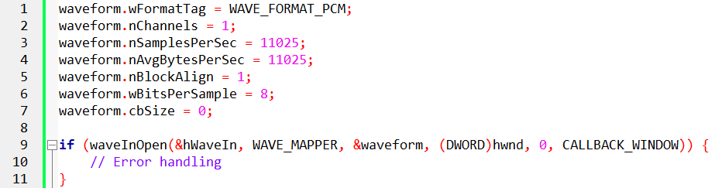

Wave Headers Setup:

Wave headers (pWaveHdr1 and pWaveHdr2) are structures that provide information about audio data. These structures are initialized with relevant details, including buffer pointers, sizes, and loop configurations. The waveInPrepareHeader function prepares these headers for use during the recording process.

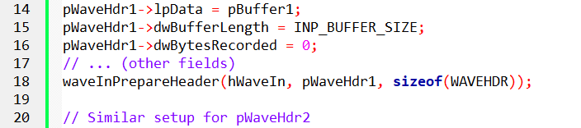

Recording Start:

Finally, the program starts the recording process by adding the initialized wave headers to the input buffer queue (waveInAddBuffer) and initiating the audio input (waveInStart).



These actions collectively set up the recording environment, ensuring that the program is ready to capture and process incoming audio data. The allocation of memory, initialization of audio input parameters, and setup of wave headers are integral to the effective handling of the recording functionality.

Recording Data Processing:

Upon receiving the MM_WIM_DATA message, the program executes crucial actions related to processing recorded data. This message signifies the availability of new audio data for the program to handle. The program responds with the following steps:

Memory Reallocation for Save Buffer:

The program reallocates memory for the save buffer (pSaveBuffer) to accommodate the incoming recorded data. The realloc function is employed to adjust the size of the save buffer, ensuring it can hold the additional data.

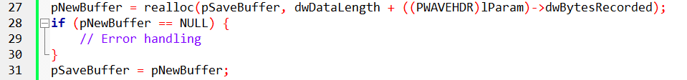

Data Copying:

The recorded data from the current buffer (lParam) is copied into the save buffer at the appropriate position. This ensures that the save buffer accumulates the complete recorded audio data.



Buffer Handling and Continuation:

If the program is in the process of ending (bEnding is true), it closes the input waveform audio device (waveInClose). Otherwise, it adds a new buffer to the input buffer queue to facilitate continuous recording.

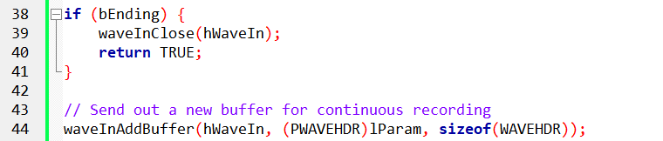

Message Processing Completion:

The function concludes by returning TRUE, indicating successful processing of the MM_WIM_DATA message.

Playing Setup:

Under the WM_COMMAND message, when the "Play Begin" button (IDC_PLAY_BEG) is pressed, the program takes specific actions to set up and commence the playback process:

Waveform Audio Output Initialization:

The program opens the waveform audio device for output (waveOutOpen). It specifies the audio format (WAVEFORMATEX) and provides information about the callback window (hwnd) to receive notifications. If the opening process encounters an error, appropriate actions are taken.

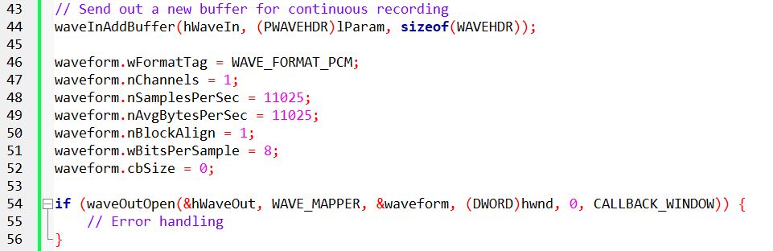

Wave Headers Setup for Playback:

Wave headers (pWaveHdr1) are initialized with relevant details, including buffer pointers, sizes, and loop configurations. The waveOutPrepareHeader function prepares these headers for use during the playback process.

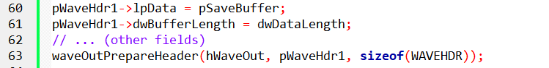

Playback Initiation:

The program initiates the playback process by writing the prepared header to the output buffer (waveOutWrite). The playback is now in progress.



These actions collectively prepare the system for audio output, initializing the waveform audio device and commencing the playback of recorded audio data. The playback setup ensures that the audio data stored in the save buffer is played through the audio output device.

Playback Data Processing:

The program handles the MM_WOM_DONE message, which is triggered when the playback of a buffer is completed. This message initiates the following actions:

Header Unpreparation and Output Closing:

The program unprepares the wave header (pWaveHdr1) and closes the waveform audio output device (waveOutClose) after the completion of buffer playback.

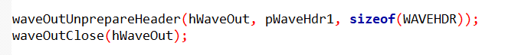

Cleanup:

Additional cleanup operations, such as resetting variables and managing the state of the program, are performed to ensure proper termination of the playback process.

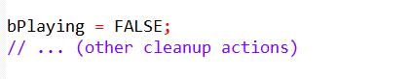

Reverse Playback Handling:

If the program was in reverse playback mode (bReverse is true), it reverses the order of bytes in the save buffer to prepare for future reverse playback.

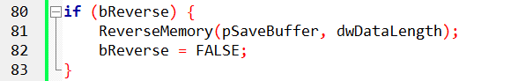

Termination Check:

If the program is in the process of terminating (bTerminating is true), it sends a close command to the main window (WM_SYSCOMMAND, SC_CLOSE).



This section of the program manages the aftermath of buffer playback, ensuring that the audio output is handled appropriately, and resources are released.

User Interaction:

The dialog procedure handles various aspects of user interaction, including enabling or disabling buttons based on the program's state. Additionally, it manages system commands, such as closing the program, under the WM_SYSCOMMAND message.

The state-dependent enabling or disabling of buttons ensures that users interact with the program in a way that aligns with its current functionality. The handling of system commands ensures a smooth and controlled termination of the program.

MORE EXPLANATIONS FOR CLARITY

Recording Sound Data Handling:

The program, during recording, continuously receives sound data through the waveInAddBuffer function and processes it using the MM_WIM_DATA message.

Recording continues until the user presses the End button (IDC_RECORD_END) or the program runs out of memory for the save buffer.

The program efficiently reallocates the save buffer using the realloc function, accommodating the growing sound data.

In case of a reallocation failure, the program gracefully handles it by calling waveInClose to stop recording.

End of Recording:

When the user presses the End button (IDC_RECORD_END), the program sets the bEnding flag to TRUE and calls waveInReset to stop recording.

The waveInReset function generates an MM_WIM_DATA message containing a partially filled buffer, and RECORD1 responds to this message, closing the waveform input device by calling waveInClose.

The waveInClose message generates an MM_WIM_CLOSE message, and RECORD1 responds by freeing the 16K input buffers and enabling/disabling appropriate push buttons.

Playback Setup and Execution:

When the user selects the Play button (IDC_PLAY_BEG), the program initializes the fields of a WAVEFORMATEX structure, calls waveOutOpen, and generates an MM_WOM_OPEN message.

During this message, the program enables/disables the appropriate push buttons, initializes the fields of the WAVEHDR structure with the save buffer, prepares it using waveOutPrepareHeader, and starts playing it with waveOutWrite.

The program processes the MM_WOM_DONE message when playback is completed, unprepares the header, and calls waveOutClose.

The waveOutClose function generates an MM_WOM_CLOSE message, and RECORD1 responds by enabling/disabling appropriate buttons.

Additional Playback Controls:

The program includes buttons for Pause, Resume, Reverse, Repeat, and Speedup during playback, each generating specific WM_COMMAND messages.

The Pause button, when pressed, calls waveOutPause to halt the sound and changes its text to "Resume." Pressing Resume resumes playback using waveOutRestart.

Reverse button reverses the order of bytes in the save buffer, enhancing the playback experience.

Repeat button utilizes the API's provision for repeating a sound by setting the dwLoops and dwFlags fields in the WAVEHDR structure.

Speedup button plays the sound twice as fast by adjusting the nSamplesPerSec and nAvgBytesPerSec fields in the WAVEFORMATEX structure.

Handling Memory Allocation and Deallocation:

The program allocates and deallocates memory for various buffers and structures during the WM_INITDIALOG, MM_WIM_OPEN, MM_WIM_DATA, MM_WIM_CLOSE, MM_WOM_OPEN, and MM_WOM_CLOSE messages.

It effectively uses realloc to adjust the size of the save buffer during recording, ensuring efficient memory usage.

MCI: A STREAMLINED APPROACH TO WAVEFORM AUDIO

While the low-level waveform audio interface offers extensive control, it can introduce complexity in terms of memory management and message handling. The Media Control Interface (MCI) emerges as a high-level alternative, providing a more streamlined approach to waveform audio tasks within Windows applications.

Key Differences and Trade-offs:

File-Based Operation: MCI operates on waveform files, recording audio data to files and playing it back from them. This contrasts with the low-level interface's direct manipulation of audio hardware.

Versatility vs. Ease of Use: The low-level interface grants greater flexibility for special effects and real-time processing, while MCI often simplifies common recording and playback scenarios.

Two Forms of MCI:

Message-Based MCI:

* Employs messages and data structures for communication with multimedia devices.
* Offers a structured approach for programmatic control.

Text-Based MCI:

* Utilizes ASCII text strings for device control.
* Designed for scripting languages but adaptable for interactive use.
* Demonstrated in the TESTMCI program.

RECORD2: A Message-Based MCI Example

* Employs message-based MCI to implement a digital audio recorder and player.
* Shares a dialog box template with RECORD1 (a low-level interface example).
* Omits special effects buttons due to MCI's file-based nature.

Considerations for Choosing an Interface:

* Special Effects: If real-time audio manipulation or special effects are crucial, the low-level interface might be necessary.
* Ease of Use: For standard recording and playback without extensive audio processing, MCI often provides a simpler development experience.
* File Handling: MCI's file-based nature can simplify file management tasks for storage and retrieval of audio data.

RECORD2.C Overview:

The RECORD2.C file encapsulates the source code for a Waveform Audio Recorder program devised by Charles Petzold in 1998.

Unlike its predecessor, RECORD1, this program streamlines sound recording and playback tasks through the utilization of the Media Control Interface (MCI).

RECORD2 primarily centers around file-based recording and playback, eschewing the incorporation of special audio effects.

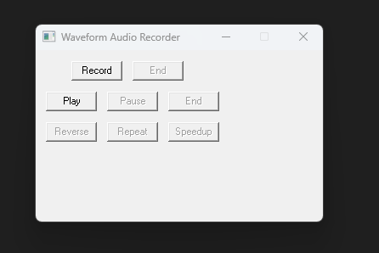

WinMain Function:

The WinMain function acts as the pivotal entry point for the application.

It endeavors to initiate the primary dialog box, defined within the DlgProc function, through the DialogBox function.

In the event that the function returns -1, indicative of an error, a message box is triggered to inform the user that the program necessitates Windows NT for proper execution.

This initial function, therefore, orchestrates the commencement of the application, attempting to establish the user interface through the designated dialog box.

The reliance on the DialogBox function underlines the event-driven nature of the graphical user interface, where user interactions with the dialog box components trigger corresponding actions within the program.

Furthermore, the Windows NT requirement is communicated to the user through a message box, enhancing the program's accessibility and providing transparency regarding its system dependencies.

ShowError Function:

The ShowError function plays a crucial role in enhancing user experience by providing clear and informative error messages in the case of MCI-related errors.

This function serves as a mechanism to bridge the gap between potentially cryptic error codes and user comprehension.

When MCI operations encounter errors, the ShowError function comes into play, leveraging the mciGetErrorString function to convert error codes into human-readable error messages.

This conversion enhances the program's user-friendliness by presenting users with intelligible information about the nature of the encountered issue.

The subsequent display of the error message within a message box, adorned with an exclamation icon, not only draws attention to the issue but also aids in rapid identification and resolution.

DlgProc Function:

The DlgProc function stands as the backbone of the program, acting as the dialog box procedure responsible for managing various messages to dictate the program's behavior.

Through the use of static variables, the function keeps track of essential states, including whether the program is currently recording, playing, or paused, as well as the filename designated for saving the recorded audio.

This meticulous state management is integral to orchestrating seamless transitions between different phases of the program's execution.

The function efficiently processes messages associated with specific buttons on the dialog box, such as record begin, record end, play begin, play pause, and play end.

Each button press triggers a series of actions, influencing the flow of the program. For instance, when the "Record Begin" button is pressed, the function initiates the recording process, updating button states and focusing on the appropriate UI elements.

Similarly, the handling of errors, as facilitated by the ShowError function, contributes to a robust and user-friendly application, ensuring that users are informed about issues promptly and comprehensibly.

The comprehensive nature of DlgProc reflects the intricate interplay between user interactions and program responses in the realm of audio recording and playback.

Recording:

Upon pressing the "Record Begin" button, the program undertakes several key actions to initiate the recording process.

Firstly, any existing waveform files are deleted, ensuring a clean slate for the upcoming recording.

Subsequently, the program leverages the Media Control Interface (MCI) to open the waveform audio device, a crucial step in preparing for recording.

This initialization phase involves configuring the necessary parameters for audio recording.

Once the setup is complete, the program commences the recording process, capturing audio input and updating the button states to reflect the ongoing operation.

This seamless integration of file management and MCI functionalities showcases the program's efficiency in handling recording tasks.

Stopping Recording:

Pressing the "Record End" button signifies the end of the recording session.

The program responds by stopping the recording process, saving the recorded audio file, and closing the waveform device.

These steps ensure the proper termination of the recording session and the preservation of the recorded audio.

Additionally, the program adjusts button states to reflect the conclusion of the recording operation, providing a clear and intuitive user interface.

Playback:

The "Play Begin" button triggers the playback functionality in the program.

Leveraging MCI, the program opens the recorded waveform file and initiates the playback process.

This phase showcases the program's versatility, seamlessly transitioning from recording to playback.

Button states are updated accordingly, reflecting the transition from the recording phase to the playback phase.

Pausing and Resuming Playback:

The "Play Pause" button introduces a dynamic element to the playback experience, allowing users to toggle between pausing and resuming playback.

This interactivity is facilitated by adjusting the button text to reflect the current state—whether it's in a paused or playing state.

Such functionality enhances user control and engagement during the playback phase.

Stopping Playback:

Pressing the "Play End" button serves as the mechanism to halt and close the playback operation.

Similar to the recording counterpart, this action ensures the proper termination of playback, and button states are updated to communicate the completion of the playback session.

MM_MCINOTIFY Handling:

The program is equipped to handle MCI notifications, specifically focusing on MCI_NOTIFY_SUCCESSFUL.

In the context of playback or recording, when this notification is received, the corresponding end actions are triggered.

This meticulous handling ensures that the program responds appropriately to the completion of these operations.

WM_SYSCOMMAND Handling:

The handling of system commands, specifically the close button (SC_CLOSE), is crucial for ensuring a clean exit from the program.

If recording or playback is in progress when the close button is pressed, the program simulates a button press to either stop recording or stop playback, ensuring proper cleanup before closing the dialog box.

This thoughtful approach enhances the user experience and prevents potential issues associated with abrupt program termination.

RECORD2 PROGRAM MORE EXPLANATION FOR CLARITY

In RECORD2, the central MCI function employed is mciSendCommand(wDeviceID, message, dwFlags, dwParam).

This function plays a pivotal role in communicating with the MCI device, utilizing various MCI command messages.

The first argument, wDeviceID, acts as a numeric identifier for the device, functioning similarly to a handle. Obtained during the device's opening, it is used consistently in subsequent mciSendCommand calls.

The second argument, message, represents MCI command messages, each prefixed with MCI. RECORD2 utilizes seven of these commands: MCI_OPEN, MCI_RECORD, MCI_STOP, MCI_SAVE, MCI_PLAY, MCI_PAUSE, and MCI_CLOSE.

These commands govern different aspects of the MCI device's behavior during recording, playback, and control operations.

The dwFlags argument in mciSendCommand generally comprises bit flag constants, combined with the bitwise OR operator, indicating various options. These options are specific to particular command messages or common across all messages.

The dwParam argument typically involves a long pointer to a data structure associated with the specific command message. These structures convey options to the device and obtain information from it. Many MCI messages have unique data structures associated with them.

The success or failure of the mciSendCommand function is indicated by its return value. A return value of zero signifies success, while an error code indicates an unsuccessful operation. To inform the user of errors, the mciGetErrorString function can be utilized, providing a text string describing the encountered error.

When the user initiates recording by pressing the "Record Begin" button, RECORD2's window procedure receives a WM_COMMAND message with wParam equal to IDC_RECORD_BEG.

Subsequently, RECORD2 opens the device by configuring an MCI_OPEN_PARMS structure and invoking mciSendCommand with the MCI_OPEN command message. The lpstrDeviceType field is set to "waveaudio" to indicate the device type for recording, and the lpstrElementName field is set to a zero-length string.

During recording, sound data is temporarily stored on the hard disk in a temporary file and is later transferred to a standard waveform file. When playing back the recorded sound, MCI utilizes the sampling rate and sample size defined in the waveform file. The specifics of waveform file formats are anticipated to be discussed later in the chapter, offering a deeper understanding of the underlying mechanisms.

Handling Device Opening Errors:

When attempting to open a device, RECORD2 checks for errors. If the device opening fails, the program utilizes mciGetErrorString and MessageBox to communicate the nature of the problem to the user. On successful device opening, the wDeviceID field of the MCI_OPEN_PARMS structure stores the device ID, crucial for subsequent calls.

Initiating Recording:

To commence recording, RECORD2 uses mciSendCommand with the MCI_RECORD command message and the MCI_WAVE_RECORD_PARMS data structure. Optionally, users can set the dwFrom and dwTo fields to insert sound into an existing waveform file. The dwCallback field is set to the program's window handle, and the MCI_NOTIFY flag ensures a notification message is sent when recording concludes.

Stopping Recording:

Pressing the first "End" button triggers the WM_COMMAND message with wParam equal to IDC_RECORD_END. In response, the window procedure calls mciSendCommand three times: MCI_STOP halts recording, MCI_SAVE transfers sound data from the temporary file to the specified file ("record2.wav"), and MCI_CLOSE deletes temporary files or memory blocks and closes the device.

Initiating Playback:

For playback, the lpstrElementName of the MCI_OPEN_PARMS structure is set to "record2.wav." The MCI_OPEN_ELEMENT flag indicates a valid filename, and the program uses the MCI_OPEN command message to open the waveform audio device, recognizing the .WAV extension.

Controlling Playback:

Playing involves an mciSendCommand call with the MCI_PLAY command message and an MCI_PLAY_PARMS structure. While any part of the file can be played, RECORD2 chooses to play it all. The "Pause" button generates a WM_COMMAND message with wParam equal to IDC_PLAY_PAUSE, prompting the program to pause or resume playback.

Ending Playback:

Pressing the second "End" button generates a WM_COMMAND message with wParam equal to IDC_PLAY_END. The window procedure responds with two mciSendCommand calls: MCI_STOP to halt playback and MCI_CLOSE to close the device.

MCI Notification Message:

The MCI notification message plays a crucial role in determining when a file has completed during playback. When a recording or playback operation is successful, the corresponding MCI_NOTIFY_SUCCESSFUL notification triggers actions in the window procedure. This ensures proper handling and synchronization, allowing the program to respond appropriately to the completion of recording or playback operations.

MCI_NOTIFY_ABORTED:

When the MCI_STOP or MCI_PAUSE command is sent via mciSendCommand, the program receives an MM_MCINOTIFY message with wParam set to MCI_NOTIFY_ABORTED. This happens when the user clicks the Pause button or either of the two End buttons. The program already handles these cases appropriately, so no further action is needed upon receiving this notification.

MCI_NOTIFY_SUCCESSFUL during playback:

When the sound file finishes playing, an MM_MCINOTIFY message is received with wParam set to MCI_NOTIFY_SUCCESSFUL. In response, the program simulates the user pressing the "End" button by sending itself a WM_COMMAND message with wParam set to IDC_PLAY_END. This triggers the program to stop playback and close the device, ensuring proper handling of the completion event.

MCI_NOTIFY_SUCCESSFUL during recording:

If the temporary sound file runs out of disk space while recording, an MM_MCINOTIFY message arrives with wParam set to MCI_NOTIFY_SUCCESSFUL. Despite the term "successful," it indicates an unexpected condition—exhaustion of storage space for the temporary file.

In this case, the program sends itself a WM_COMMAND message with wParam set to IDC_RECORD_END. The program then stops recording, saves the file, and closes the device, following the normal procedures despite the unexpected completion event.